PHYSICS

(SCIENCE PAPER 1)

Maximum Marks: 80

Time allowed: Two hours

Answers to this Paper must be written on the paper provided separately.

You will not be allowed to write during first 15 minutes.

This time is to be spent in reading the question paper.

The time given at the head of this Paper is the time allowed for writing the answers.

Section A is compulsory. Attempt any four questions from Section B.

The intended marks for questions or parts of questions are given in brackets [ ].

SECTION A (40 Marks)

(Attempt all questions from this Section.)

Question 1
Choose the correct answers to the questions from the given options. | [15]
(Do not copy the questions, write the correct answers only.)

- When a bell fixed on a cycle rings, then the energy conversion that takes place is:

  - gravitational potential energy to sound energy

  - kinetic energy to sound energy

  - sound energy to electrical energy

  - sound energy to mechanical energy

- A door lock is opened by turning the lever (handle) of length 0.2 m. If the moment of force produced is 1 Nm, then the minimum force required is:

  - 5 N

  - 10 N

  - 20 N

  - 0.2 N

This Paper consists of 12 printed pages.
T24 521 Turn Over

© Copyright reserved.

- A force ‘F’ moves a load from A to C as shown in the figure below. For the calculation of the work done, which of these lengths would you use as the displacement?

  - 3m

  - 4m

  - 5m

  - 7m
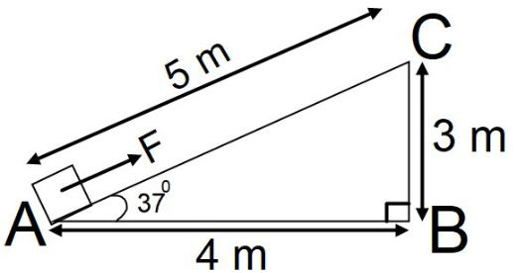

- A radioactive nucleus containing 128 nucleons emits a β – particle. After β – emission the number of nucleons present in the nucleus will be:

  - 128

  - 129

  - 124

  - 127

- Assertion (A): Ultraviolet radiations are scattered more as compared to the microwave radiations.

Reason (R): Wavelength of ultraviolet radiation is more than the wavelength of microwave radiation.

  - Both A and R are true.

  - A is true but R is false.

  - A is false but R is true.

  - Both A and R are false.

- When the stem of vibrating tuning fork is pressed on a table, the tabletop starts vibrating. These vibrations are definitely an example of:

  - resonance

  - natural vibrations

  - forced vibrations

  - damped vibrations

T24 521 2

- Which of the following is a class III lever?

  - Pair of scissors

  - Wheelbarrow

  - Crowbar

  - Human forearm

- The specific resistance of a conductor depends on its:

  - length

  - material

  - area of cross section

  - radius

- Identify the option that displays the correct wiring with correct colour code:

(a) (b)
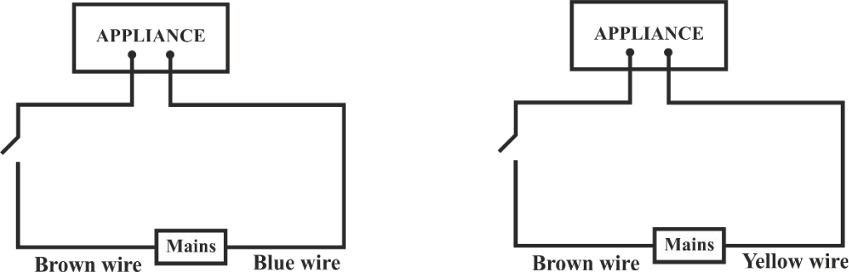

(c) (d)
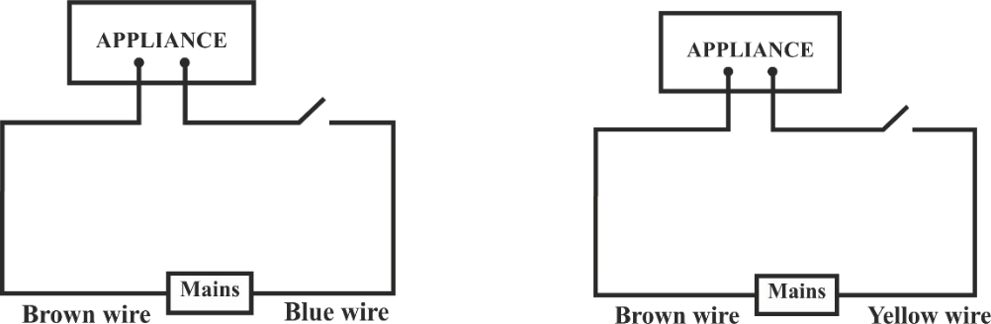

T24 521 3 Turn Over
- The potential difference between terminals of a cell in a closed electric circuit is:

  - terminal voltage

  - electro motive force

  - voltage drop

  - none of these

- During melting of ice at 0°C the:

  - energy is released and temperature remains constant.

  - energy is absorbed and temperature remains constant.

  - energy is released and temperature decreases.

  - energy is absorbed and temperature increases.

- Linear magnification(m) produced by a concave lens is:

  - m < 1

  - m > 1

  - m = 1

  - m = 2

- A radioactive element is placed in an evacuated chamber. Then the rate of radioactive decay will:

  - Decrease

  - Increase

  - Remain unchanged

  - Depend on the surrounding temperature

T24 521 4

- The graph given below shows heat energy supplied against change in temperature when no energy is lost to the surrounding. The slope of this graph will give:

  - Specific heat capacity

  - Latent heat of fusion

  - Latent heat of vaporization

  - Heat capacity

- A block of glass is pushed into the path of the light as shown below. Then the converging point X will:
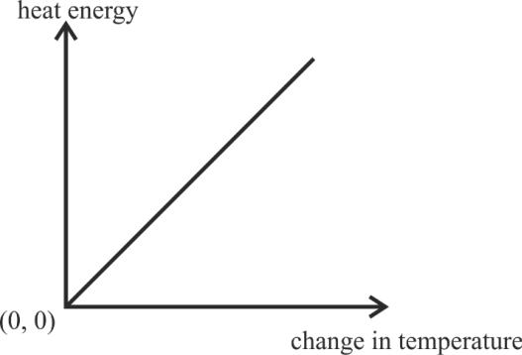
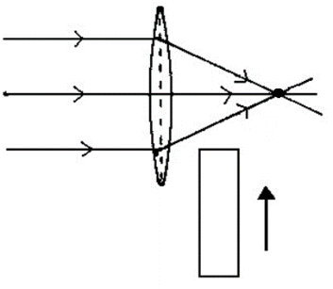
(a) Move away from the slab X

- Move towards the slab

- Not shift

- Move towards the left side of the lens

B

L
O
C

K

Question 2
(i) | (a) In the following atoms, which one is a radioisotope? Give one use of this isotope. | [3]
 | O¹⁶, C¹⁴, N¹⁴, He⁴

(b) Name the class of the lever shown in the picture below:
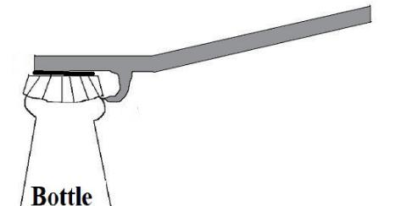

(ii) Fill in the blanks: [2]

- When a stone tied to a string is rotated in a horizontal plane, the tension in the string provides __________ force necessary for circular motion.

- Work done by this force at any instant is __________.

T24 521 5 Turn Over

(iii) | A non uniform beam of weight 120 N pivoted at one end is shown in the diagram below. |  | [2]
 | Calculate the value of F to keep the beam in equilibrium.
 |  | C.G.
 |  | 0.80 m
(iv) | Meera chose to use a block and tackle system of ‘9’ pulleys instead of a single movable |  | [2]
 | pulley to lift a heavy load.
 | (a) What is the advantage of using a block and tackle system over a single movable
 |  | pulley?
 | (b) Why should she connect more number of pulleys in the upper fixed block?
(v) | Sumit does 600 J of work in 10 min and Amit does 300 J of work in 20 min. Calculate |  | [2]
 | the ratio of the powers delivered by them.
(vi) | 5 bulbs are connected in series in a room. One bulb is fused. It is removed and |  | [2]
 | remaining 4 bulbs are again connected in series to the same circuit. What will be the
 | effect on the following physical quantities? (Increases, Decreases, Remain Same)
 | (a) | Resistance
 | (b) | Intensity of light
(vii) | Rohan conducted experiments on echo in different media. He observed that a minimum |  | [2]
 | distance of ‘x’ meters is required for the echo to be heard in oxygen and ‘y’ meters in
 | benzene. Compare ‘x’ and ‘y’. Justify your answer.
 | Speed of sound in oxygen: 340 ms⁻¹
 | Speed of sound in benzene: 200 ms⁻¹
Question 3
(i) | (a) In a reading glass what is the position of the object with respect to the convex lens |  | [2]
 |  | used?
 | (b) Why can we not use concave lens for the same purpose?
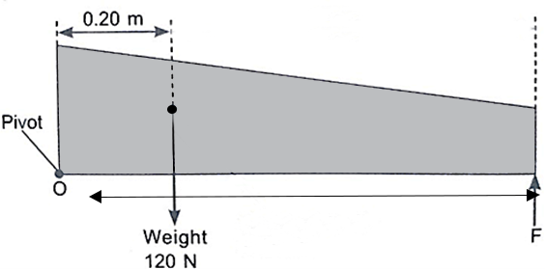

T24 521 6

(ii) | A fuse is rated 5 A. Can it be used with a geyser rated 1540 W, 220 V. Write Yes or |  |  |  | [2]
 | No. Give supporting calculations to justify your answer.
(iii) | State two factors affecting the speed of rotation of the coil in a D.C. motor. |  |  |  | [2]
(iv) | How much heat is required to convert 500 g of ice at 0ºC to water at 0ºC? The latent |  |  |  | [2]
 | heat of fusion of ice is 330 Jg⁻¹.
(v) | Copy and complete the nuclear reaction by filling in the blanks. |  |  |  | [2]
 | 92U²³⁵ + 0n¹ |  |  | 56Ba⁻⁻⁻ + --- Kr⁹² + 3 0n¹
 |  |  |  | SECTION B (40 Marks)
 |  | (Attempt any four questions from this Section.)
Question 4
(i) | The image of a candle flame placed at a distance of 36 cm from a spherical lens, is |  |  |  | [3]
 | formed on a screen placed at a distance of 72 cm from the lens. Calculate the focal
 | length of the lens and its power.
(ii) | Below is an incomplete table showing the arrangement of electromagnetic spectrum |  |  |  | [3]
 | in the increasing order of their wavelength. Complete the table.

Gamma | X – ray | U V | Visible
ray | X – ray | rays | rays

Infrared

A

Radio

waves

- Identify the radiation A.

- Name the radiation used to detect fracture in bones.

- Name one property common to both A and Radio waves.

(iii) (a) Why do we use red colour as a danger signal on the top of a skyscraper? [4]

- The diagram below shows the path of a blue ray through the prism: 1. Calculate the critical angle of the
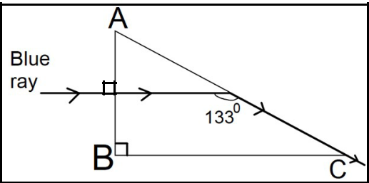
material of the prism for blue colour.

  - What is the measure of the angle of this prism (A)?

- Which colour should replace the blue ray, for the ray to undergo Total Internal Reflection?

T24 521 7 Turn Over

Question 5

- (a) Refractive index of glass with respect to water is ₈⁹. Find the refractive index of water with respect to glass.
  - Name the principle used to find the value in part (a).
  - If we change the temperature of water, then will the ratio ⁹ remain the
same? Writeor .⁸

- Light travels a distance of ‘10x’ units in time ‘t1’ in vacuum and it travels a distance of ‘x’ units in time ‘t2’ in a denser medium. Using this information answer the question that follows:

  - ‘Light covers a distance of ‘20x’ units in time ‘t1’ in diamond.’ State true or false.

  - Calculate the refractive index of the medium in terms of ‘t1’ and ‘t2’.

- A monochromatic ray of light is incident on an equilateral prism placed at minimum deviation position with an angle of incidence 45° as shown in the diagram.

  - Copy the diagram and complete the path of the ray PQ.

  - State two factors on which the angle of deviation depends.
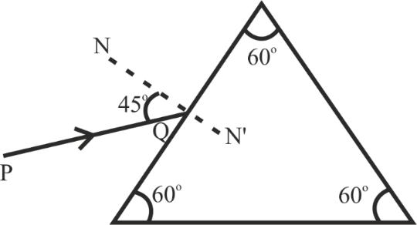

[3]

[3]

[4]

Question 6

(i) (a) Define Centre of Gravity. [3]

- A hollow ice cream cone has height 6 cm.

  - Where is the position of its centre of gravity from the broad base?

    - Will its position change when it is filled completely with honey? Write Yes or No.

T24 521 8

_{(ii)} Marble
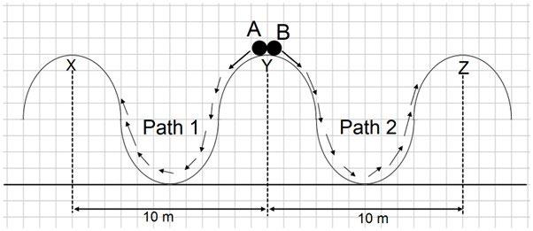

Two identical marbles A and B are rolled down along Path 1 and Path 2 respectively.

Path 1 is frictionless and Path 2 is rough.

  - Which marble will surely reach the next peak?

  - Along which path/s the mechanical energy will be conserved?

  - Along which path/s is the law of conservation of energy obeyed?

- Given are two pulleys.

  - Copy and complete the labelled diagram connecting the two pulleys with a tackle to obtain Velocity Ratio = 2.

  - If Load = 48 kgf and efficiency is 80% then calculate:

    - Mechanical Advantage.

    - Effort needed to lift the load.
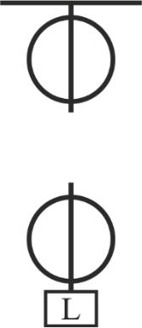

Question 7

- (a) Name the waves used in SONAR.

(b)
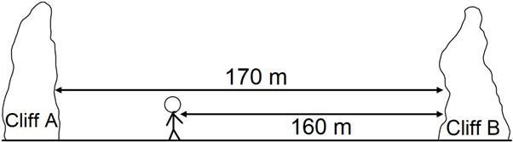

In the above diagram Lata stands between two cliffs and claps her hands.

Determine the time taken by her to hear the first echo.

Speed of sound in air 320 ms⁻¹.

[3]

[4]

[3]

T24 521 9 Turn Over

^{(ii)} ^{(a)} ^{Complete}−→ ^{the⬚following}+4→^{radioactive}234+ ^{reaction:}
2 91 −1

  - Uranium is available in two forms U-235 and U-238. Which of the two isotopes of Uranium is more fissionable?

- In the given diagram, a vibrating tuning fork is kept near the mouth of a burette filled with water. The length of the air column is adjusted by opening the tap of the burette. At a length of 5 cm of the air column, a loud sound is heard.
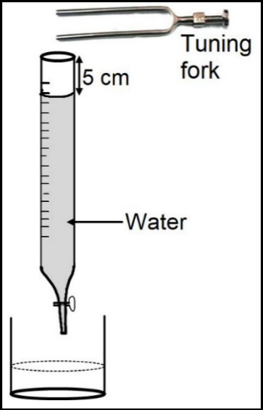

- Name the phenomenon illustrated by the above experiment.

- Why is a loud sound heard at this particular length?

- If the present tuning fork is replaced with a tuning fork of higher frequency, should the length of the air column increase or decrease to produce a loud sound? Give a reason.

Question 8
(i) | The voltage - current readings of a certain material are shown in the table given below:
 |  |  | Voltage (V) |  | 10 V | 20 V | 30 V
 |  |  | Current (I) |  | 2 A | 3 A | 4 A
 | Study the table.
 | (a) State whether the conductor used is ohmic or non-ohmic.
 | (b) | Justify your answer.
 | (c) | State Ohm’s law.

[3]

[4]

[3]

T24 521 10

(ii) Below is the diagram of a transformer: [3]

iron core
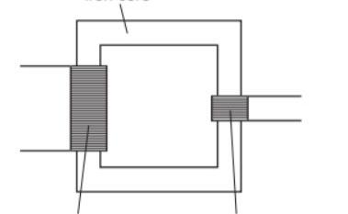

primary coil secondary coil

- Identify the type of transformer.

- In this type of transformer which of the wire is thicker, the primary or the secondary? Give a reason.

(iii) Study the diagram: [4]
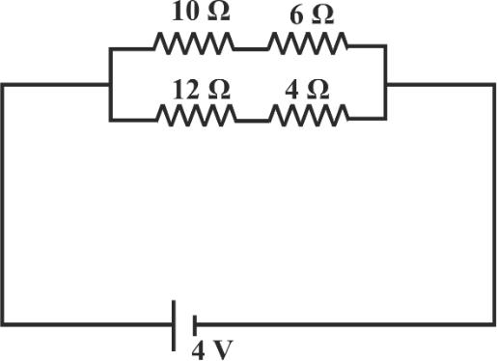

- Calculate the total resistance of the circuit.

- Calculate the current drawn from the cell.

- State whether the current through 10 Ω resistor is greater than, less than or equal to the current through the 12 Ω resistor.

T24 521 11

Question 9
(i) | 85 g of water at 30ºC is cooled to 5ºC by adding certain mass of ice. Find the mass of |  | [3]
 | ice required.
 | [Specific heat capacity of water = 4.2 Jg^{-1o}C⁻¹, Specific latent heat of fusion = 336 Jg⁻¹]
(ii) | (a) | Why does it become pleasantly warm when the lakes start freezing? | [3]
 | (b) | Water freezes to form ice. What change would you expect in the average kinetic
 |  | energy of the molecules?
 | (c) | Which will contain more heat energy 1 g of ice at 0ºC or 1 g water at 0ºC?

(iii) (a) State one factor that affects the magnitude of induced current in an AC generator. [4]

- Given below is a circuit to study the magnetic effect of electric current. ABCD is a cardboard kept perpendicular to the conductor XY. A magnetic compass is placed at the point P of the cardboard. P1 and P2 are the positions of the magnetic compass, before and after passing a current through XY respectively.
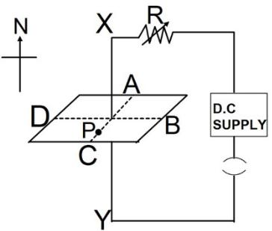

 P1

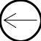 P2

- Name the rule that is used to predict the direction of deflection of the magnetic compass.
  - State the direction of current in the conductor (X to Y or Y to X) when the circuit is complete.

- If resistance R is increased, then what will be the effect on the magnetic lines of force around the conductor?

T24 521 12

