MATHEMATICS

Maximum Marks: 80

Time allowed: Two and half hours

Answers to this Paper must be written on the paper provided separately.

You will not be allowed to write during first 15 minutes.

This time is to be spent in reading the question paper.

The time given at the head of this Paper is the time allowed for writing the answers.

Attempt all questions from Section A and any four questions from Section B.

All working, including rough work, must be clearly shown, and must be done on the same sheet as the

rest of the answer.

Omission of essential working will result in loss of marks.

The intended marks for questions or parts of questions are given in brackets [ ]

Mathematical tables and graph papers are to be provided by the school.

SECTION A (40 Marks)

(Attempt all questions from this Section.)

Question 1

Choose the correct answers to the questions from the given options. | [15]

(Do not copy the questions, write the correct answers only.)

- For an Intra-state sale, the CGST paid by a dealer to the Central government is

` 120. If the marked price of the article is ` 2000, the rate of GST is:

- 6%

- 10%

- 12%

- 16.67%

This paper consists of 12 printed pages.
T24 511 Turn Over

© Copyright reserved.

- What must be subtracted from the polynomial x³ + x² – 2x + 1, so that the result is exactly divisible by (x – 3)?

  - – 31

  - – 30

  - 30

  - 31

- The roots of the quadratic equation px² – qx + r = 0 are real and equal if:

  - p² = 4qr

  - q² = 4pr

  - – q² = 4pr

  - p² > 4qr
(iv) | If matrix |  | 2 | 2� | and | 2 | 4 |  | , then the value of x is:
 |  |  | = �₀ | 2� |  |  | = �₀ | 4�
  - 2

  - 4

  - 8

  - 10

- The median of the following observations arranged in ascending order is 64. Find the value of x:

27, 31, 46, 52, x, x + 4, 71, 79, 85, 90

  - 60

  - 61

  - 62

  - 66

- Points A (x, y), B (3, -2) and C (4, -5) are collinear. The value of y in terms of x is∶

  - 3x – 11

  - 11 - 3x

  - 3x – 7

  - 7 – 3x

T24 511 2

(vii) | The given table shows the distance covered and the time taken by a train moving
 | at a uniform speed along a straight track.
 |  |  | Distance (in m) |  |  |  |  |  |  |  | 60 |  |  |  |  | 90 | y
 |  |  | Time (in sec) |  |  |  |  |  |  |  | 2 |  |  |  |  | x | 5
 | The values of x and y are:
 | (a) x = 4, y = 150
 | (b) x = 3, y = 100
 | (c) x = 4, y = 100
 | (d) x = 3, y = 150
(viii) | The 7th term of the given Arithmetic Progression (A.P.):
 |  |  | 1 |  |  |  |  |  |  | 1 | , � | 1 | +1�,� |  | 1 | + 2� … is:
 | (a) |  |  |  |  |  | + 6�
 |  |  | �
 | (b) |  | 1 |  |  |  | + 7�
 |  |  | �
 | (c) |  | 1 |  |  |  | + 8�
 |  |  | �
 | (d) |  | 1 |  |  |  |  | 7
 |  |  | � |  |  |  | + 7 |  | �
- The sum invested to purchase 15 shares of a company of nominal value ` 75 available at a discount of 20% is:

  - ` 60

  - ` 90

  - ` 1350

  - ` 900

- The circumcentre of a triangle is the point which is∶

  - at equal distance from the three sides of the triangle.

  - at equal distance from the three vertices of the triangle.

  - the point of intersection of the three medians.

  - the point of intersection of the three altitudes of the triangle.

T24 511 3 Turn Over
(xi) | Statement 1: | sin | 2 | ₂+ cos | 2 | ₂ | = 1
 | Statement 2: | sin |  | ₂+ cos |  | ₂ | = 1
 | Which of the | cosec + cot |  |  |  |  | = 1
 |  | following is valid?

- only 1

- only 2

- both 1 and 2

- neither 1 nor 2
- the given diagram, PS∠and PT are the tangents to the circle. SQ || PT and
∠^{In}SPT = 80°. The value of QST is:
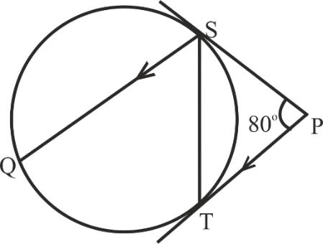
  - 140°

  - 90°

  - 80°

  - 50°

- Assertion (A): A die is_{is} thrown. once and the probability of getting an even number

Reason (R): The sample space for even numbers on a die is {2, 4, 6}

(a) A is true, R is false.

(b) A is false, R is true.

(c) Both A and R are true.

(d) Both A and R and false.

(xiv) | A rectangular sheet of paper of size 11 cm x 7 cm is first rotated about the side
 | 11 cm and then about the side 7 cm to form a cylinder, as shown in the diagram.
 | The ratio of their curved surface areas is:
 | (a) | 1 | ∶ | 1
 | (b) | 7 | ∶ | 11 |  | 7
 | c) | 11 |  |  | 7 | 7
 | c) |  | ∶ | ∶ | 7
 | (d) |  | 7 |  | ∶ | 11
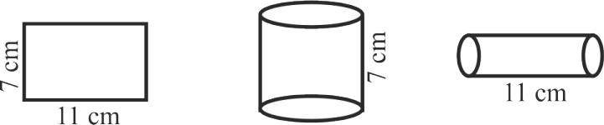

T24 511 4

- In the given diagram, ∆ABC ∼ ∆PQR. If AD and PS are bisectors of ∠BAC and

∠QPR respectively then:

  - ∆ABC ∼ ∆PQS

  - ∆ABD ∼ ∆PQS

  - ∆ABD ∼ ∆PSR

  - ∆ABC ∼ ∆PSR
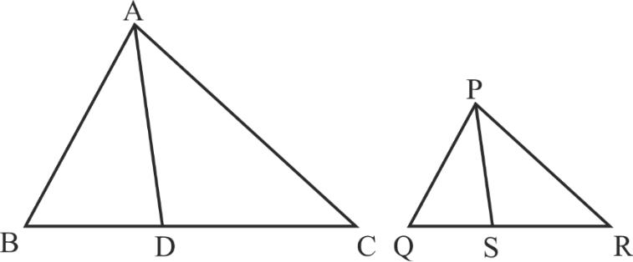
Question 2 |  | ⁰�, = �⁴ | ⁰� =�⁴ |  | 0�
(i) | = � | ⁰�, = �⁴ |  |  | 0� | [4]
 | Find the values of x |  | 1 | AB=C | 1
 | 1 | 1 |  |  | 1
 |  | and y, if |  | .
(ii) | A solid metallic cylinder is cut into two identical halves along its height (as shown |  |  |  |  | [4]
 | in the diagram). The diameter of the cylinder is 7 cm and the height is 10 cm. Find:

- The total surface area (both the halves).

- The total cost of painting the two halves at the rate of ` 30 per cm²
� = �
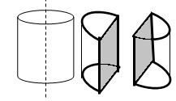

(iii) 15, 30, 60, 120… are in G.P. (Geometric Progression). [4]

- Find the n^{th} term of this G.P. in terms of n.

- How many terms of the above G.P. will give the sum 945?

Question 3
(i) | Factorize: ³ + ³ |  |  | [4]
 | Hence, prove the following identity:
 |  | 3 + cos3 |  | + sin= 1
 |  | sin + cos |  | + sin= 1
T24 511 |  | 5 |  | Turn Over

(ii) In the given diagram, O is the centre of the circle. PR and PT are two tangents [4]

drawn from the external point P and touching the circle at Q and S respectively.

MN is a diameter of the circle. Given ∠PQM = 42º and ∠PSM = 25º.
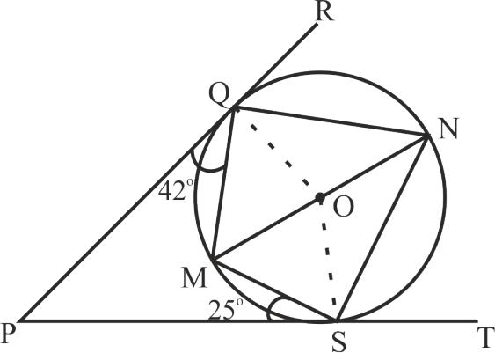

Find:

- ∠OQM

- ∠QNS

- ∠QOS

- ∠QMS

(iii) Use graph sheet for this question. Take 2 cm = 1 unit along the axes. [5]

- Plot A(0, 3), B(2, 1) and C(4, -1).

- Reflect point B and C in y-axis and name their images as B' and C' respectively. Plot and write coordinates of the points B' and C'.
- Reflect point A in the line BB' and name its images as A'.

- Plot and write coordinates of point A'.

- Join the points ABA'B' and give the geometrical name of the closed figure so formed.

SECTION B (40 Marks)

(Attempt any four questions from this Section.)

Question 4
(i) | Suresh has a recurring deposit account in a bank. He deposits ` 2000 per month and the |  |  |  |  |  |  |  |  | [3]
 | bank pays interest at the rate of 8% per annum. If he gets ` 1040 as interest at the time of
 | maturity, find in years total time for which the account was held.
(ii) | The following table gives the duration of movies in minutes. |  |  |  |  |  |  |  |  | [3]
 | Duration | 100 – 110 | 110 – 120 | 120 – 130 | 130 – 140 |  | 140 – 150 | 150 – 160
 | (in minutes) |  |  |  |  |  | 140 – 150 | 150 – 160
 | No. of | 5 | 10 | 17 | 8 |  | 6 | 4
 | movies |  |  |  |  |  | 6 | 4

Using step – deviation method, find the mean duration of the movies.

T24 511 6

(iii) |  | (−⁺)3 |  | = | 27⁶⁴ | [4]
 | (a) | Find | +
 | (a) | Find | −

(b) Hence using properties of proportion, find a : b.

Question 5
(i) | The given graph with a histogram represents the number of plants of different heights | [5]
 | grown in a school campus. Study the graph carefully and answer the following questions:
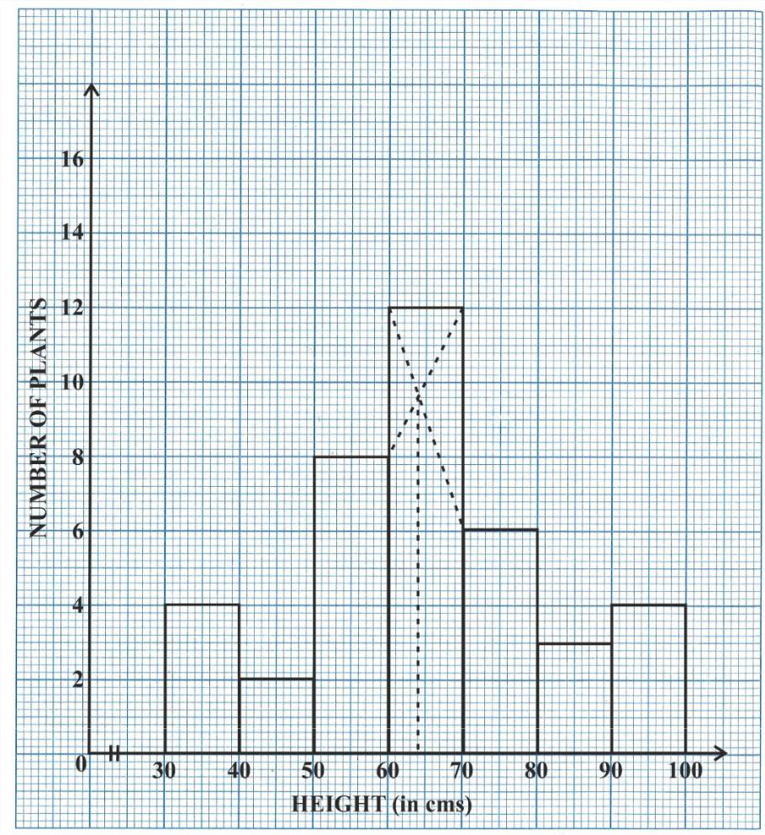

- Make a frequency table with respect to the class boundaries and their corresponding frequencies.

- State the modal class.

- Identify and note down the mode of the distribution.

- Find the number of plants whose height range is between 80 cm to 90 cm.

T24 511 7 Turn Over
(ii) The angle of elevation of the top of a 100 m high tree from two points A and B on the [5]

opposite side of the tree are 52º and 45º respectively. Find the distance AB, to the nearest metre.
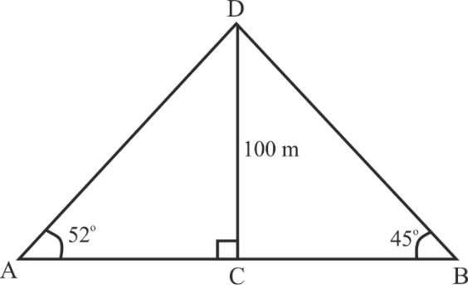

Question 6
(i) | Solve the following quadratic equation for x and give your answer correct to three |  |  |  | [3]
 | (Use mathematical |  |  | –+ =
 | significant figures:
 |  | tables if necessary)
(ii) | The n^{th} term of an Arithmetic Progression (A.P.) is given by the relation Tn = 6(7 – n). |  |  |  | [3]
 | Find∶
- its first term and common difference

- sum of its first 25 terms

(iii) In the given diagram ∆ADB and ∆ACB are two right angled triangles with [4] ∠ADB = ∠BCA = 90º. If AB = 10 cm, AD = 6 cm, BC = 2.4 cm and DP = 4.5 cm
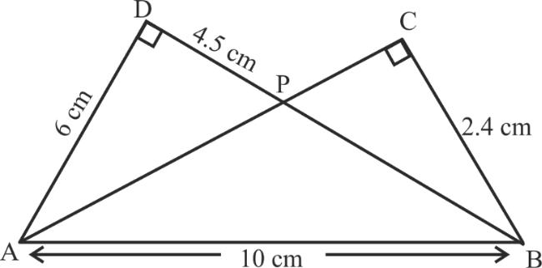

- Prove that ∆APD ∼ ∆BPC

- Find the length of BD and PB

- Hence, find the length of PA

- Find area ∆APD : area ∆BPC

T24 511 8

Question 7

- In the given diagram, an isosceles ∆ABC is inscribed in a circle∠with centre O. [3] PQ is a tangent to the circle at C. OM is perpendicular to chord AC and COM = 65°.
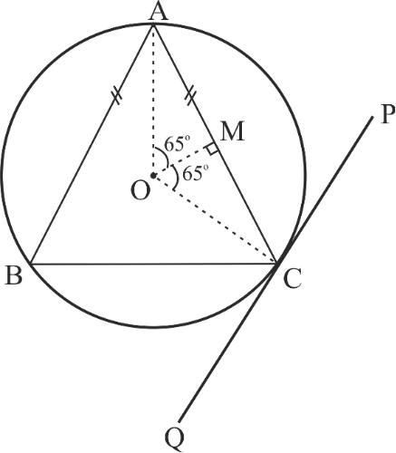

Find:

- ∠ABC

- ∠BAC

- ∠BCQ

(ii) | Solve the following inequation, write down the solution set and represent it on the real |  |  |  | [3]
 | number line. | −3+ ≤ | 7 | +2<8+2 ,
 | number line. | −3+ ≤ | 2 | +2<8+2 ,
(iii) | In the given diagram, ABC is a triangle, where B(4,– 4) and C(– 4, – 2). D is a point on |  |  |  | [4]
 | AC.
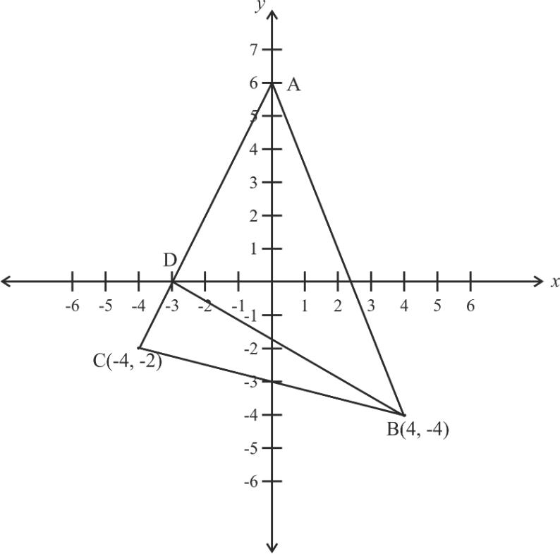

- Write down the coordinates of A and D.

- Find the coordinates of the centroid of ∆ABC.

- If D divides AC in the ratio k : 1, find the value of k.

- Find the equation of the line BD.

T24 511 9 Turn Over
Question 8
(i) | The polynomial 3x³ + 8x² – 15x + k has (x – 1) as a factor. Find the value of k. Hence | [3]
 | factorize the resulting polynomial completely.
(ii) | The following letters A, D, M, N, O, S, U, Y of the English alphabet are written on separate | [3]
 | cards and put in a box. The cards are well shuffled and one card is drawn at random. What
 | is the probability that the card drawn is a letter of the word,
 | (a) MONDAY?
 | (b) which does not appear in MONDAY?
 | (c) which appears both in SUNDAY and MONDAY?
(iii) | Oil is stored in a spherical vessel occupying 3/4 of its full capacity. Radius of this spherical | [4]
 | vessel is 28 cm. This oil is then poured into a cylindrical vessel with a radius of 21 cm.

Find the height of the oil in the cylindrical vessel (correct to the nearest cm).
=
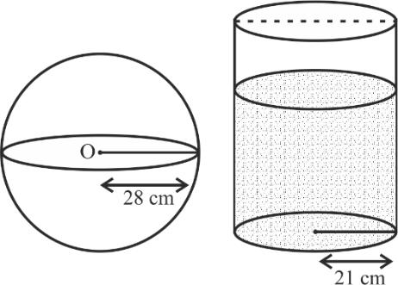

Question 9
(i) | The figure shows a circle of radius 9 cm with O as the centre. The diameter AB produced | [3]
 | meets the tangent PQ at P. If PA = 24 cm, find the length of tangent PQ.
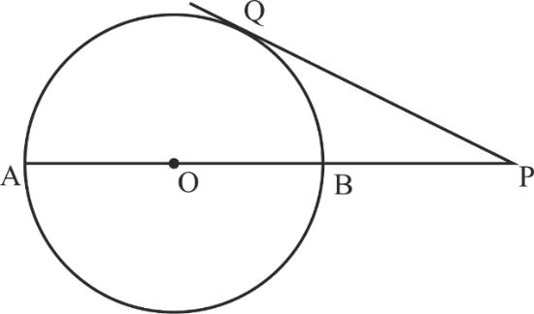

T24 511 10

(ii) | Mr. Gupta invested ` 33000 in buying ` 100 shares of a company at 10% premium. The |  |  |  |  |  | [3]
 | dividend declared by the company is 12%. Find:
 | (a) | the number of shares purchased by him.
 | (b) | his annual dividend.
(iii) | A life insurance agent found the following data for distribution of ages of 100 policy |  |  |  |  |  | [4]
 | holders:
 |  | Age in years |  | Policy Holders | Cumulative frequency
 |  |  |  | (frequency)
 |  | 20–25 |  | 2 | 2
 |  | 25–30 |  | 4 | 6
 |  | 30–35 |  | 12 | 18
 |  | 35–40 |  | 20 | 38
 |  | 40–45 |  | 28 | 66
 |  | 45–50 |  | 22 | 88
 |  | 50–55 |  | 8 | 96
 |  | 55–60 |  | 4 | 100

On a graph sheet draw an ogive using the given data. Take 2 cm = 5 years along one axis and 2 cm = 10 policy holders along the other axis. Use your graph to find:

- The median age.

- Number of policy holders whose age is above 52 years.

Question 10
(i) | Rohan bought the following eatables for his friends : |  |  |  |  |  | [3]
 |  |  |  | Soham Sweet Mart : Bill
 |  | S. No. | Item | Price |  | Quantity | Rate of GST
 |  | 1 | Laddu | ` 500 per kg |  | 2 kg | 5%
 |  | 2 | Pastries | ` 100 per piece |  | 12 pieces | 18%

Calculate :

- Total GST paid.

- Total bill amount including GST.

T24 511 11 Turn Over
(ii) | (a) | If the lines kx – y + 4 = 0 and 2y = 6x + 7 are perpendicular to each other, find the | [3]
 |  | value of k.
 | (b) | Find the equation of a line parallel to 2y = 6x + 7 and passing through (–1, 1)
(iii) | Use ruler and compass to answer this question. Construct ∠ABC = 90º, where |  | [4]
 | AB = 6 cm, BC = 8 cm.

- Construct the locus of points equidistant from B and C.

- Construct the locus of points equidistant from A and B.

- Mark the point which satisfies both the conditions (a) and (b) as O. Construct the locus of points keeping a fixed distance OA from the fixed point O.

- Construct the locus of points which are equidistant from BA and BC.

T24 511 12

