HISTORY & CIVICS

(H.C.G. Paper – 1)

 |  | Maximum Marks: 80
 |  | Time allowed: Two hours
 | Answers to this Paper must be written on the answer sheet provided separately.
 |  | You will not be allowed to write during the first 15 minutes.
 |  | This time is to be spent in reading the question paper.
 | The time given at the head of this Paper is the time allowed for writing the answers.
 |  | Attempt all questions from Part I (Compulsory).
 | A total of five questions are to be attempted from Part II, two out of three questions from
 |  | Section A and three out of five questions from Section B.
 | The intended marks for questions or parts of questions are given in brackets [ ].
 |  | PART I (30 Marks)
 |  | (Attempt all questions from this Part.)
Question 1
Select the correct answers to the questions from the given options. |  |  | [16]
(Do not copy the questions, write the correct answer only).
(i) | The salaries and allowances of the ministers are decided by the:
 | (a) | Parliament
 | (b) | Finance Minister
 | (c) | President
 | (d) | Prime Minister

- Civil Cases : Court of District Judge : : Criminal Cases :

  - Revenue Court

  - Family Court

  - Sessions Court

  - Commissioner’s Court

 | This paper consists of 8 printed pages.
T24 501 | Turn Over
© Copyright reserved.

(iii)
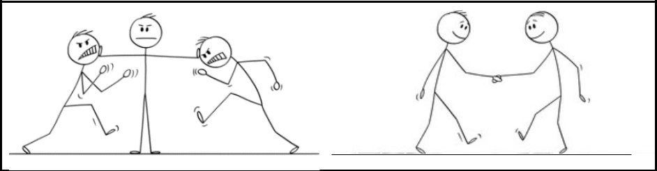

The Lok Adalat has many advantages. Which of the following statements about the advantages of the Lok Adalat is best described in the picture given above?

  - It is inexpensive

  - It is organised in various parts of the country

  - It works on the spirit of compromise

  - It reduces the burden of the higher courts

- Given below are details of Indian citizens. Select the ones who are eligible for appointment as a High Court Judge:
Candidate | Age | Details
P | 65 | Is a distinguished jurist
Q | 61 | Has been a High Court Advocate for 10 years
R | 67 | Has been a High Court Advocate for 5 years
S | 56 | Has held a judicial office for at least 10 years

  - P and R

  - Q and S

  - R and P

  - Q and R

- The strength of the house is 550. On a particular day 50 members are present. The speaker decides to adjourn the house. Identify the MOST LIKELY reason for the adjournment.

  - Disorder in the house

  - Lack of quorum

  - Breach of privilege

  - Contempt of the House

T24 501 2

- During a hung assembly when no party gets the majority, the President appoints the Prime Minister. What power is the President exercising?

  - Legislative

  - Executive

  - Discretionary

  - Judicial

- Read the two statements given below and select the option that shows the correct relationship between (A) and (R):

Assertion (A): Forward Bloc had the objective of abolishing Zamindari System.

Reason (R):Subhash Chandra Bose wanted to establish a socialist state.

  - A is true but R is false

  - R is the reason for A

  - Both A and R are false

  - Only R is true, A is false

- The ___________ aimed to introduce equality between British and Indian Judges.

  - Vernacular Press Act

  - Gagging Act

  - Indian Universities Act

  - Ilbert Bill

- The Rowlatt Act was called the Black Act because the Indians:

  - could not possess any arms

  - could not export any goods

  - could be arrested without a warrant

  - could be sent overseas on duty

- Who organised the Grand Delhi Durbar?

  - Lord Curzon

  - Lord Canning

  - Lord Lytton

  - Lord Dalhousie

T24 501 3 Turn Over

- Tina is inspired by the methods of the Early Nationalists and wants to follow them. She notices that the road leading to her school is damaged and has many potholes. Which of the following methods is she MOST LIKELY to follow, to solve this problem?

  - Boycott the civic authorities

  - Gather a group of students and protest

  - Write a petition to the authorities highlighting the problem

  - Block the entrance to the road

- Given below are the objectives of the Indian National Army. Identify the odd one out of the following:

  - To organise a provisional government of Free India

  - Total mobilisation of Indian manpower and money

  - Unity, faith and sacrifice

  - To train and organise public opinion in the country

- Tahir is preparing to give a speech about the Sati system in India. Which of the following Indian leader’s contribution MUST he mention in his speech?

  - Raja Rammohan Roy

  - W. C. Bonerjee

  - Bipin Chandra Pal

  - Jyotiba Phule

- Which of the following is NOT a consequence of the Second World War?

  - Austria and Hungary became separate states

  - Defeat of the Axis powers

  - Beginning of the Cold War

  - Formation of the United Nations

- Identify the principle of Panchsheel.

  - Mutual non-aggression

  - Regulate armaments

  - Take action against aggressor

  - Recommend admission of members

T24 501 4

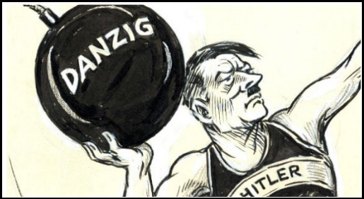
(xvi)

By Milton Rawson Halladay

Which incident depicted in the above cartoon led to the beginning of the Second World War?

- Hitler’s policy of Imperialism

- Hitler’s attack on Poland

- Hitler’s annexation of Austria

- Hitler’s attack on Czechoslovakia

Question 2

(i) Mention any two writs issued by the High Court. [2]

- Imagine you are an Indian ruler who has signed the Subsidiary Alliance. Mention [2] any two conditions of this agreement which will affect you.

(iii) | Mention any two causes of the Quit India Movement. | [2]
(iv) | In which year did the Surat Split happen? What was the result of this split? | [2]
(v) | Mention any two common ideologies of Fascism and Nazism. | [2]
(vi) | Name the two cities of Japan which were bombed by America in the year 1945. | [2]
(vii) | Read the given news carefully and answer the question that follows: | [2]

Govt’s power to promulgate, repromulgate Ordinances — why and how

An Ordinance “shall have the same force and effect as an Act of Parliament”. But the government is required to bring an Ordinance before Parliament for ratification — and failure to do so will lead to its lapsing “at the expiration of six weeks from the reassembly of Parliament”.

The Indian Express – May 25, 2023

Mention any two points regarding an ordinance that can be deduced from the above news.

T24 501 5 Turn Over

PART II

SECTION A (20 Marks)

(Attempt any two questions from this Section.)

Question 3

The Union Parliament is the supreme legislative body in the country. With reference to the

Indian Parliament answer the following questions:

(i) | The Rajya Sabha is called a Permanent House. Explain this statement. | [3]
(ii) | Explain the composition of the Rajya Sabha. | [3]
(iii) | Mention any two exclusive powers of the Lok Sabha and two powers exclusive to | [4]
 | the Rajya Sabha.

Question 4

The Council of Ministers headed by the Prime Minister aids and advises the President. In this context, answer the following questions:

(i) | Mention any three points to distinguish between the Council of Ministers and the | [3]
 | Cabinet.
(ii) | Who appoints the Cabinet Ministers? Mention any two administrative powers of | [3]
 | the Cabinet.
(iii) | The President is the nominal head of the Indian Union. Mention any four functions | [4]
 | of the Prime Minister with reference to the President.

Question 5

The judiciary is the system of courts that interprets and guards the Indian Constitution. With reference to the Supreme Court of India, answer the following:

(i) | What is the composition of the Supreme Court? Why is it called the Court of | [3]
 | Record?
(ii) | Explain the power of Judicial Review. | [3]
(iii) | What is meant by the term Original Jurisdiction? Mention any three cases which | [4]
 | come under this jurisdiction.
T24 501 | 6

SECTION B (30 Marks)

(Attempt any three questions from this Section.)

Question 6

The Revolt of 1857 was the beginning of the independence struggle against the colonial rule of the British. With reference to the consequences of the Revolt, answer the following:

(i) | Mention any three changes made in the administration with the end of the | [3]
 | Company’s Rule.
(ii) | State any three policies promised to Indians in Queen Victoria’s Proclamation. | [3]
(iii) | Mention any four changes made in the army after the Revolt. | [4]

Question 7

The Indian National Movement is divided into three phases. With reference to the Second Phase of the Indian National Movement, answer the following questions:

(i) | Who partitioned Bengal? Mention any two points to explain the perspective of the | [3]
 | Nationalists regarding the actual motive behind the decision of Partition.
(ii) | What was the objective of the Assertive Nationalists? Mention any two | [3]
 | contributions of Bal Gangadhar Tilak.
(iii) | In which year was the Muslim League formed? Mention any three objectives of | [4]
 | the Muslim League.

Question 8

Look at the picture given and answer the following questions:
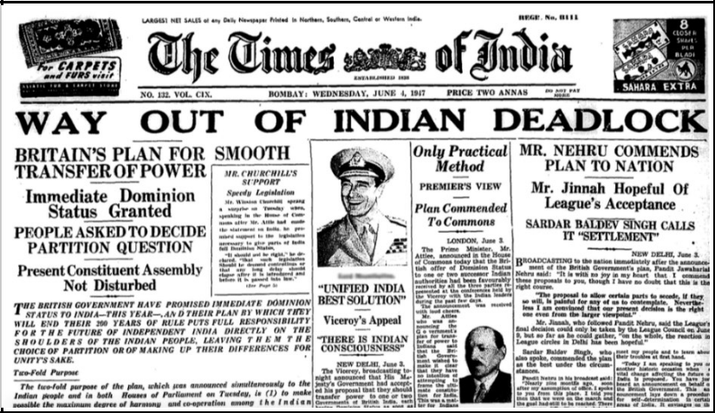

T24 501 7 Turn Over

(i) | Name the Viceroy who announced the plan for smooth transfer of power. Mention | [3]
 | any two clauses of his plan with reference to the Princely States.
(ii) | Mention any three reasons for the acceptance of his plan by the Congress. | [3]
(iii) | Mention any four provisions of the Indian Independence Act of 1947. | [4]

Question 9

The final act of the long-drawn-out negotiations took place at Versailles on Saturday afternoon, and to-day Germany and the Allies – always with the exception of America – are at peace. Peace is a blessed word, and both the word and the fact are welcome to-day. So far as Germany is concerned there is for the present an end of strife, and at least a formal return to the decent relations of civilised states.

 | Editorial: Peace in force (12 January 1920)
 | The Guardian
(i) | Mention any three causes of the World War which ended with the signing of the | [3]
 | treaty being discussed in the passage above.
(ii) | Name the organization which was established in 1920 to maintain peace after this | [3]
 | war. Mention any two of its objectives.
(iii) | Mention any four clauses of the Treaty which affected Germany. | [4]

Question 10

Both the United Nations Organisation and the Non-Aligned Movement aim to achieve international peace and security. In this context, answer the following:

(i) | Mention any three functions of the Security Council. | [3]
(ii) | Mention any three functions of the World Health Organisation. | [3]
(iii) | Name any two founders of the Non-Aligned Movement. Mention any two of its | [4]
 | objectives.

T24 501 8

