GEOGRAPHY

(H.C.G. PAPER – 2)

Maximum Marks: 80

Time allowed: Two hours

Answers to this paper must be written on the answer sheet provided separately.

You will not be allowed to write during the first 15 minutes.

This time is to be spent in reading the question paper.

The time given at the head of this Paper is the time allowed for writing the answers.

Part I is compulsory. All questions from Part I are to be attempted.

A total of five questions are to be attempted from Part II.

The intended marks for questions or parts of questions are given in brackets [ ].

To be supplied with this paper: Survey of India Map Sheet No. G43S7 and 20 cm of twine.

Note:

- In all map work, make wise use of arrows to avoid overcrowding of the map.

- The extract of Survey of India Map Sheet No. G43S7 must not be taken out of the examination hall. It must be handed over to the Supervising Examiner on completion of the paper.

- The map given at the end of this question paper must be detached, and after marking, must be fastened to your answer booklet.

- All sub-sections of the questions attempted must be answered in the correct serial order.

- All working including rough work should be done on the same answer sheet which is used to answer the rest of the paper.

This paper consists of 10 printed pages and 1 outline map of India.

T24 502 Turn Over

© Copyright reserved.
 | PART I (30 Marks)
 | (Attempt all questions from this Part.)
Question 1
Study the extract of the Survey of India Map Sheet No. G43S7 and answer the
following questions:
(i) | (a) Give the six-figure grid reference for spot height .522. | [2]
 | (b) What is the pattern of settlement in the grid square 3591?
(ii) | (a) Mention two man-made features seen in the grid square 3794. | [2]
 | (b) Mention two means of transport used by the people of Nani Bhatamal in
 | the grid square 3691.
(iii) | (a) Identify the landform marked by the contours in the grid square 3896. | [2]
 | (b) What is the pattern of drainage seen in the grid square 3697?
(iv) | (a) What is the reason for the presence of causeway in the grid square 3695? | [2]
 | (b) What is the compass direction of Khara (4097) from Karja (3994)?
(v) | Calculate the area in kilometre square of the region to the south of 94 Northing. | [2]
Question 2
On the outline map of India provided:
(i) | Mark and label the river Krishna. | [1]
(ii) | Mark and label the Eastern Ghats. | [1]
(iii) | Shade and label a densely populated area in the southern part of India. | [1]
(iv) | Shade and label the Konkan coastal plain. | [1]
(v) | Mark with an arrow and label the direction of western disturbance. | [1]
(vi) | Shade and label the Thar Desert. | [1]
T24 502 | 2

(vii) | Shade and label the Andaman Sea. | [1]
(viii) | Mark and label the city Chennai. | [1]
(ix) | Mark and name the highest peak of Himalayas in India. | [1]
(x) | Mark and label Mumbai High. | [1]
Question 3
Choose the correct answers to the questions from the given options. |  | [10]
(Do not copy the questions, write the correct answers only.)

- What causes snowfall in Kashmir during winter?

  - Tropical cyclone

  - Northeast Monsoon wind

  - Southwest Monsoon wind

  - Temperate cyclone

- Which of the following helps in soil conservation?

  - Afforestation

  - Overgrazing

  - Mining

  - Shifting agriculture

- Which means of irrigation can be developed with minimum expenditure?

  - Tube well

  - Canal

  - Well

  - Drip irrigation

T24 502 3 Turn Over

- Read the table and identify the pair that is correctly matched:

 | Natural Vegetation | Tree
 | Belt | Tree
P | Tropical evergreen | Babool
Q | Tropical deciduous | Teak
R | Littoral | Ebony
S | Mountain forest | Banyan

  - P

  - Q

  - R

  - S

- Bauxite is the ore of:

  - Aluminium

  - Copper

  - Manganese

  - Iron

- Identify the source of energy that leads to pollution:

  - Tidal energy

  - Wind energy

  - Natural gas

  - Geo-thermal energy

- Which of the following is NOT a centre for the iron and steel industry?

  - Bhilai

  - Bengaluru

  - Rourkela

  - Vishakhapatnam

T24 502 4

- Which of the following farming method is used to grow tea on a large scale?

  - Subsistence farming

  - Plantation farming

  - Mixed farming

  - Shifting agriculture

- Which of the following means of transport has best use during floods / earthquake?

  - Airways

  - Railways

  - Roadways

  - Waterways

- Which of the following is a biodegradable waste?

  - Broken glass

  - Wastepaper

  - Polythene

  - Plastic bags

PART II (50 Marks)

(Attempt any five questions from this Part.)

Question 4
(i) | ‘Himalayas act as a climatic divide.’ Justify the statement giving two reasons. | [2]
(ii) | Differentiate between Southwest Monsoon and Retreating Monsoon. (Any two | [2]
 | differences)
(iii) | Give a geographical reason for the following: | [3]

(a) Kolkata gets more rain than Delhi during rainy season.

(b) Though both are hill stations, Shimla experiences snowfall during the winters but Ooty does not.

(c) Winter monsoons bring less rain.

T24 502 5 Turn Over

(iv) Study the climate data of Station X and answer the questions that follow: |  |  |  |  |  |  |  |  |  |  |  | [3]
Month | Jan | Feb | Mar | Apr | May | Jun | Jul | Aug | Sep | Oct | Nov | Dec
Temp | 8.4 | 11.5 | 21.6 | 28.3 | 35.1 | 38.5 | 41.0 | 38.0 | 30.8 | 29.2 | 15.6 | 10.2
C
Rainfall | 1.5 | 0.9 | 0.5 | _ | _ | 12.5 | 17.8 | 18.5 | 12.5 | 12.5 | 6.2 | 2.1
cms

- Calculate the annual range of temperature of Station X.

- Name the rainiest month of the Station X.

- Is the Station X located in coastal area or in the continental interior?

Question 5
(i) | Why is Black soil found suitable for the production of cotton? (Any two points) | [2]
(ii) | Give one difference between each of the following: | [2]
 | (a) Alluvial soil of Uttarakhand and alluvial soil of West Bengal.
 | (b) Transported soil and residual soil.
(iii) | With reference to Laterite soil, answer the questions that follow: | [3]
 | (a) How is Laterite soil formed?
 | (b) How can Laterite soil be made productive?
 | (c) Name one region where Laterite soil is found.
(iv) | (a) Mention two causes of soil erosion in India. | [3]
 | (b) Mention a soil conservation method suitable for hilly area.
Question 6
(i) | How is tropical monsoon forest useful for the Indian economy? (Any two points) | [2]
(ii) | Mention the climatic condition that leads to the development of tropical desert | [2]
 | vegetation.
T24 502 | 6

(iii) Give a reason to explain each of the following: [3]

- Mountains have varied vegetation.

- Stilt like / aerial roots are a typical feature of littoral forest.

- The tropical evergreen forests do not look bare at any time of the year.

(iv) (a) How has the rising population of India resulted in the loss of forest cover? [3]

(Any one point)

- Mention any two forest conservation methods that may be adopted to protect the forests.

Question 7
(i) | Mention one advantage and one disadvantage of using tank irrigation. |  | [2]
(ii) | (a) | What is the advantage of using Drip irrigation? | [2]
 | (b) | Why is Drip irrigation not practiced on a large scale in India?
(iii) | Give a reason to explain each of the following: |  | [3]

- Sprinkler irrigation is gaining popularity in recent times.

- Tube well irrigation is used in Punjab.

- North India has more area under canal irrigation.

(iv) | [3]
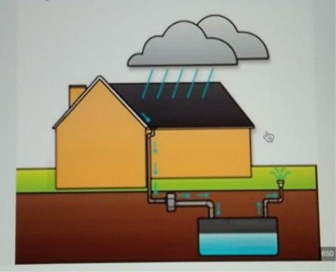

- Name the water conservation practice shown in the above picture.

- How does this system help to reduce floods?

- Why is water conservation necessary? (Any two reasons)

T24 502 7 Turn Over

Question 8
(i) | (a) | Name any three varieties of coal produced in India. | [2]
 | (b) | Name the variety of coal widely used in Iron and Steel Industries of India.
(ii) | (a) | Name the state that is the largest producer of iron ore in India. | [2]

- Name any one mining area of Iron ore from the state mentioned by you.

(iii) (a) Mention two ways in which Hirakud dam has helped the people of Odisha? | [3]

- Across which river is the Hirakud dam built?

(iv) Give reasons for each of the following: [3]

- Geothermal energy is not popular in India.

- Solar energy is gaining popularity.

- Petroleum is considered a harmful source of energy.

Question 9
(i) | Why is agriculture considered an important sector of Indian economy? (Any two | [2]
 | points)
(ii) | (a) What is mixed farming? | [2]
 | (b) Mention any one advantage of mixed farming.
(iii) | Give one reason to explain each of the following: | [3]
 | (a) West Bengal is a leading producer of jute.
 | (b) Millets are fast becoming the popular food crops.
 | (c) More than two ratoon crops are not advisable for sugarcane farmers.
(iv) | (a) With reference to tea cultivation, explain the term ‘fine pluck’. | [3]
 | (b) Name the Indian state that leads in coffee production.
 | (c) Why is cotton grown as a Kharif crop in India?

T24 502 8

Question 10

- (a) Based on the ownership, what type of industry is Visakhapatnam Steel Plant? [2]

  - What is meant by cooperative sector industry?

(ii) Explain the following terms: [2]

- Sericulture

- Integrated steel plant

(iii) Give one reason to explain each of the following: [3]

- Mini-steel plants help in conservation of coal.

- Location of sugar industry is shifting to the southern part of India.

- The electronic industry is growing at a fast rate.

(iv) | (a) | State two conditions that favour the location of cotton textile industry in | [3]
 |  | Ahmedabad.
 | (b) | State any one advantage of locating Iron and Steel industry at Rourkela.

Question 11
(i) | Why is road transport an important means of transport in India? (Any two | [2]
 | reasons)
(ii) | Give a reason for each of the following: | [2]
 | (a) Northern plain is best suited for the development of Railways.
 | (b) Railways are managed completely by the Central Government.
(iii) | Mention two advantages and one disadvantage of Inland water transport. | [3]
(iv) | Why has airway become more popular than other means of transport? (Any three | [3]
 | reasons)

T24 502 9 Turn Over

Question 12

(i) With reference to the picture below, answer the questions that follow: [2]
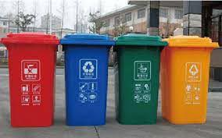

- Which waste management method is depicted here?

- State one way in which this method may be implemented at our home.

(ii) | Explain how waste accumulation can be harmful. (Any two points) |  | [2]
(iii) | Explain how waste generated in following sectors may be made useful. (Give |  | [3]
 | one example for each)
 | (a) | Household
 | (b) | Industry
 | (c) | Agriculture
(iv) | (a) | Give two uses of composting. | [3]

- Why are landfills set up far away from the city? (Any two reasons)

T24 502 10

Question No. 2

Index No.……………………………………………. UID……………………………..

(This map, if used, must be fastened with all other answers)

Outline Map of India for Question 2.
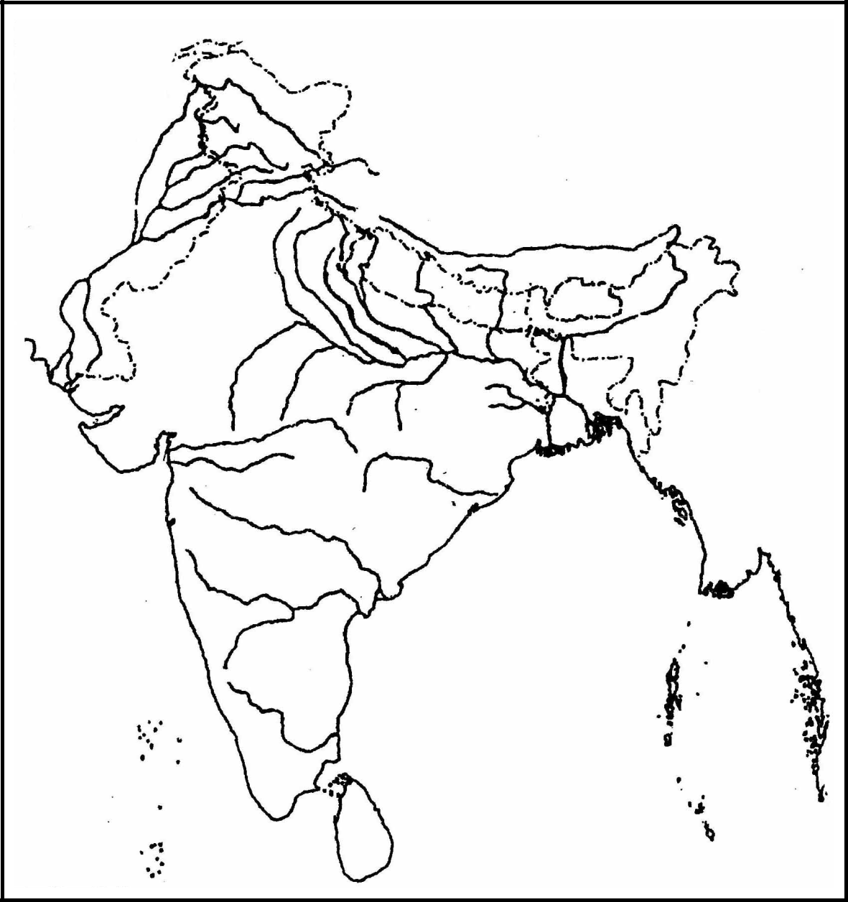

 | ONLY FOR THE EXAMINER
(i) | (ii)(iii) (iv)(v)(vi) (vii) (viii) (ix)(x) | Total

T24 502 11

