BIOLOGY

(SCIENCE PAPER – 3)

Maximum Marks: 80

Time allowed: Two hours

Answers to this Paper must be written on the paper provided separately.

You will not be allowed to write during first 15 minutes.

This time is to be spent in reading the question paper.

The time given at the head of this Paper is the time allowed for writing the answers.

Section A is compulsory. Attempt any four questions from Section B.

The intended marks for questions or parts of questions are given in brackets [ ].

SECTION A (40 Marks)

(Attempt all questions from this Section.)

Question 1
Select the correct answers to the questions from the given options. |  |  | [15]
(Do not copy the questions, write the correct answer only).
(i) | Duplicated chromosomes are joined at a point termed:
 | (a) | Centrosome
 | (b) | Centromere
 | (c) | Centriole
 | (d) | Chromatid

- The process of conversion of ADP to ATP during photosynthesis is called:

  - Photolysis

  - Phagocytosis

  - Photophosphorylation

  - Polymerisation

This paper consists of 11 printed pages and 1 blank page.
T24 523 Turn Over

© Copyright reserved.

- The process in which water is lost from the margins of strawberry leaves is:

  - Osmosis

  - Imbibition

  - Diffusion

  - Guttation

- The hormone that affects urination is:

  - Adrenaline

  - Vasopressin

  - Oestrogen

  - Thyroxine

- Which one of the following helps in the opening of stomata:

  - Cobalt ions

  - Potassium ions

  - Magnesium ions

  - Aluminium ions

- A zygote which has Y chromosome inherited from the father will develop into a:

  - Will depend on the chromosome inherited from the mother

  - Girl

  - Either boy or a girl

  - Boy

- The ear ossicle that transports sound vibrations to the inner ear:

  - Stapes

  - Malleus

  - Incus

  - Cochlea

T24 523 2
- If a person has a heart attack, what must be done immediately?

    - Loosen his/her clothing

    - Make him/her lie down in an airy room

    - Rush him/her to the hospital

    - Engage him/her in a conversation

  - P and Q

  - P and S

  - R and S

  - P, Q and R

- Adjusting the focal length of the eye lens to view objects at different distances is done by:

  - Cornea

  - Iris

  - Ciliary muscles

  - Sclera

- Four friends P, Q, R and S were discussing the examples of genetic disorders. The examples they quoted were as follows:

    - Colour blindness and Malaria

    - Albinism and Cholera

    - Haemophilia and Colour blindness

    - Haemophilia and Albinism

- P and Q

- R and S

- P and R

- Q and S

T24 523 3 Turn Over
- Osmosis takes place when there is:

  - A freely permeable membrane

  - A cell wall

  - A selectively permeable membrane

  - An impermeable membrane

- A male gorilla has 48 chromosomes in each of its body cells. How many chromosomes will each of the sperms have?

  - 24

  - 48

  - 12

  - 16

- Assertion (A): Sympathetic nervous system prepares the body for violent action against abnormal conditions.
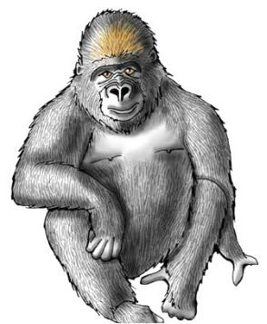

  - Both A and R are True

  - A is True, R is False

  - A is False but R is True

  - Both A and R are False

- Birth rate is the number of live births per thousand persons in:

  - 1 year

  - 2 years

  - 10 years

  - 20 years

T24 523 4
- Industrial Melanism was observed in:

  - Mice

  - Peppered Moth

  - House Flies

  - Crow

Question 2

(i) Name the following: [5]

- Unicellular outgrowths from the epidermis of roots.

- A defect in our eyes, in which some parts of the object are in focus while the other parts are blurred.

- The tropic movement of plant parts in response to chemicals.

- The main nitrogenous waste formed in the body.

- The process of attachment of fertilized ovum to the wall of uterus.

(ii) Arrange and rewrite the terms in each group in the correct order to be in a [5]

logical sequence beginning with the term that is underlined:

- Australopithecus, Cro-Magnon, Homo erectus, Neanderthal man.

- Pupil, Aqueous humour, Retina, Vitreous humour.

- Effector, Receptor, Motor neuron, Sensory neuron.

- Loop of Henle, Distal convoluted tubule, Bowman’s Capsule, Proximal convoluted tubule.

- Water vapour, Soil water, Leaves, Ascent of Sap

T24 523 5 Turn Over
(iii) Study the diagram given below and fill in the blanks with suitable words: [5]
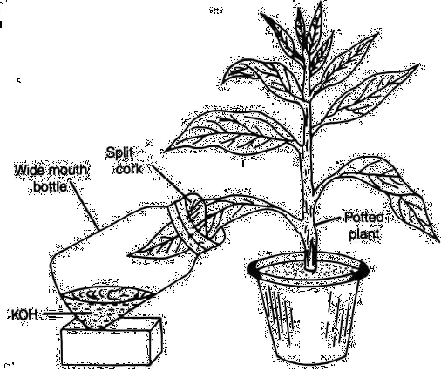

In order to prove that carbon dioxide is necessary for (a) ___________, a potted

plant is placed in dark for 48 hours to (b) __________ the leaves. A part of a leaf is

inserted into a conical flask containing potassium hydroxide solution. This is to absorb (c) ___________ from the flask. The plant is then placed in sunlight for a few

hours. The experimental leaf is tested for starch. The part of the leaf that was inside the conical flask turns (d) ___________, whereas the part of the leaf outside turns

- __________ in colour.

(iv) Choose the odd one out from the following terms and name the category to which [5]

the others belong:

- Prothrombin, Thrombin, Fibrinogen, Albumin

- Tonsils, Glomerulus, Spleen, Lymph nodes

- Neutrophils, Basophils, Monocytes, Eosinophils

- Leaves, Styrofoam, Grass, Cow Dung

- Pulmonary artery, Renal artery, Coronary artery, Hepatic artery

T24 523 6
(v) | Match the items given in Column I with most appropriate ones in Column II and |  |  |  | [5]
 | rewrite the correct matching pairs:
 |  | Column I |  | Column II
 | (a) | Leydig Cells | 1. | Lack of thyroxine in children
 | (b) | Stoma | 2. | 12 pairs
 | (c) | Ova | 3. | Testosterone
 | (d) | Cranial nerve | 4. | Diffusion of respiratory gases
 | (e) | Cretinism | 5. | Haploid cells
 |  |  | 6. | 31 Pairs
 |  |  | 7. | Diploid cells
 |  |  | SECTION B (40 Marks)
 |  | (Attempt any four questions from this Section.)
Question 3
(i) | Expand the abbreviation-NADP. |  |  |  | [1]
(ii) | Mention two adaptations in roots for absorption of water from the soil. |  |  |  | [2]
(iii) | Differentiate between Afferent arteriole and Efferent arteriole (diameter). |  |  |  | [2]
(iv) | Give two examples of water pollutants. |  |  |  | [2]
(v) | Ali has some pea plants in his garden which need a support to grow as seen in the |  |  |  | [3]
 | picture given below:
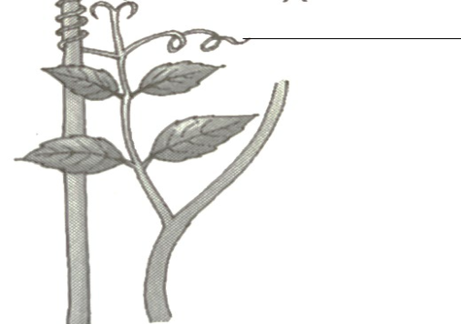

X

- Name the phenomenon depicted by the shoot in the given figure.

- Define the above phenomenon.

- Write the name of the part marked X.

T24 523 7 Turn Over
Question 4
(i) | Give the biological term for the surgical method of contraception in human females. | [1]
(ii) | State two harmful effects of acid rain on the environment. | [2]
(iii) | Mention two advantages of Transpiration. | [2]
(iv) | Write any two objectives of Swachh Bharat Abhiyan. | [2]
(v) | Mohan is fond of playing basketball. His concentration is on shooting the ball into | [3]
 | the opponent’s basket as given in the picture.
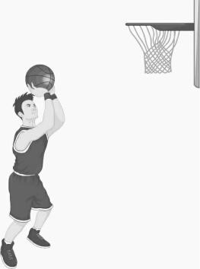

- Which part of the brain helps Mohan to concentrate in putting the ball into the basket?

- Name the sense organ that helps to gauge the distance between the ball and the basket.

- Name the part of the brain that co-ordinates all the voluntary muscles of his body.

Question 5
(i) | Name the type of nerve which has the fibres of both sensory and motor neurons. |  | [1]
(ii) | Differentiate between Australopithecus and Modern man based on body hair. |  | [2]
(iii) | “Birth rate in India is very high.” Mention two reasons in support of the statement. |  | [2]
(iv) | Give the exact location of: |  | [2]
 | (a) | Pericardium
 | (b) | Bicuspid valve
T24 523 |  | 8

(v) | Given below is a schematic representation of the inheritance of the shape of seeds of | [3]
 | garden pea. Answer the questions that follow:
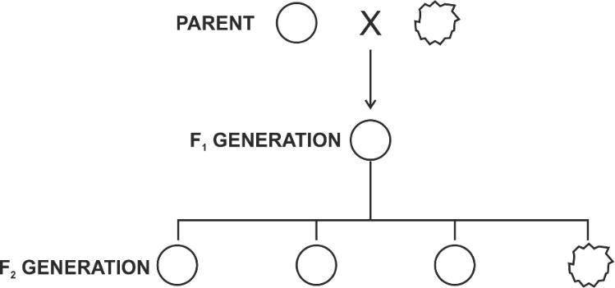

- Which is the dominant and recessive allele of the trait?

- What does the ratio 3 : 1 in the F2 generation represent?

- State Mendel’s Law of Dominance.

Question 6
(i) | Define the term-Diapedesis. | [1]
(ii) | Distinguish between Diabetes mellitus and Diabetes insipidus (endocrine gland | [2]
 | concerned).
(iii) | Carbon monoxide is dangerous when inhaled in excess. Comment on the statement. | [2]
(iv) | The diagram given below shows a section of the human ovary. | [2]
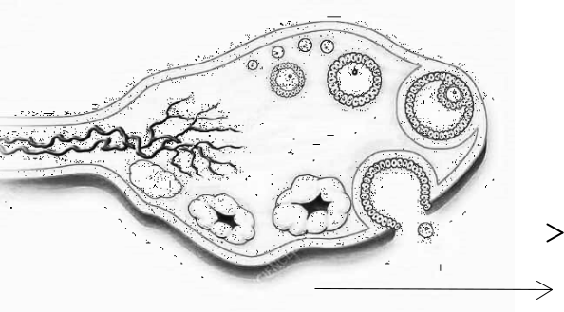

 |  |  |  | 1
 |  |  |  | 2
 | (a) Name the process for the release of the part labelled 1. |  |  | 2
 | (b) Write the name of the structure marked 2.
(v) | Draw a neat, labelled diagram of a chloroplast. |  |  | [3]
T24 523 | 9 |  |  | Turn Over

Question 7
(i) | Define the term hormone. |  | [1]
(ii) | Which parts of the ear are responsible for: |  | [2]
 | (a) | Static equilibrium?
 | (b) | Dynamic equilibrium?
(iii) | Mention two structural differences between an artery and a vein. |  | [2]
(iv) | Write any two limitations of using a Ganong’s Potometer to demonstrate the uptake |  | [2]
 | of water.
(v) | A teacher drew the diagram of heart on the blackboard and told the students to copy |  | [3]
 | it in their notebooks. Mahesh couldn’t see the diagram clearly as it appeared blurred
 | to him.

- Name the defect of the eye Mahesh is suffering from.

- Where is the image formed in this defect?

- Mahesh consults an eye doctor and is prescribed suitable lenses to correct the defect. Which type of lens do his spectacles have?

Question 8
(i) | Define the term ultrafiltration. |  | [1]
(ii) | Name the mineral elements required for: |  | [2]
 | (a) | Clotting of blood
 | (b) | Synthesis of thyroxine
(iii) | Mention two harmful effects of noise pollution. |  | [2]
(iv) | Why are RBCs efficient in their functions though they lack nucleus and |  | [2]
 | mitochondria?

T24 523 10
(v) The diagram given below represents a stage in mitosis. [3]
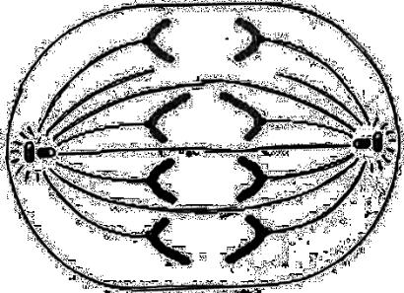

- Identify the stage given above.

- Give one reason to support your answer in (a).

- Mention the number of chromosomes given in the diagram.

T24 523 11

