PHYSICS

SCIENCE Paper – 1

(Two hours)

Answers to this Paper must be written on the paper provided separately.

You will not be allowed to write during the first 15 minutes.

This time is to be spent in reading the Question Paper.

The time given at the head of this Paper is the time allowed for writing the answers.

Section I is compulsory. Attempt any four questions from Section II.

The intended marks for questions or parts of questions are given in brackets [ ].

SECTION I (40 Marks)
Attempt all questions from this Section

Question 1
- The diagram below shows a claw hammer used to remove a nail:

[2]

Claw hammer
Nail

  - To which class of lever does it belong?

  - Give one more example of the same class of lever mentioned by you in (i) for which the mechanical advantage is greater than one.

- Two bodies A and B have masses in the ratio 5:1 and their kinetic energies are in the ratio 125:9. Find the ratio of their velocities.
[2]

- (i) Name the physical quantity which is measured in calories.

(ii) How is calorie related to the S.I unit of that quantity?
[2]

This Paper consists of 9 printed pages and 1 blank page.
T19 521 Turn over
© Copyright reserved.

- (i) Define couple.

(ii) State the S.I. unit of moment of couple.
[2]

- (i) Define critical angle.

(ii) State one important factor which affects the critical angle of a given medium.
[2]

Question 2
- An electromagnetic radiation is used for photography in fog.

  - Identify the radiation.

  - Why is this radiation mentioned by you, ideal for this purpose?

[2]

- (i) What is the relation between the refractive index of water with respect to air (aµw) and the refractive index of air with respect to water (wµa).
[2]

(ii) If the refractive index of water with respect to air (aµw) is .
5
3

Calculate the refractive index of air with respect to water (wµa).

- The specific heat capacity of a substance A is 3,800 Jkg-1K-1 and that of a substance B is 400 Jkg-1K-1. Which of the two substances is a good conductor of heat? Give a reason for your answer.

[2]

- A man playing a flute is able to produce notes of different frequencies. If he closes the holes near his mouth, will the pitch of the note produced, increase or decrease? Give a reason.
[2]

- 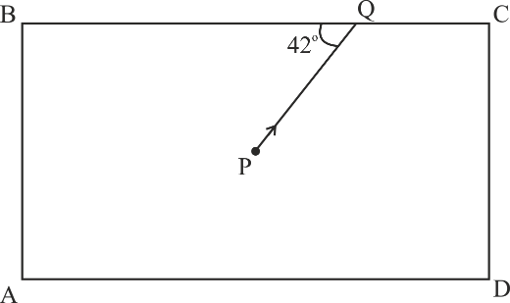The diagram below shows a light source P embedded in a rectangular glass block ABCD of critical angle 42o. Complete the path of the ray PQ till it emerges out of the block. [Write necessary angles.]
[2]

Question 3
- (i) If the lens is placed in water instead of air, how does its focal length change?
(ii) Which lens, thick or thin has greater focal length?

[2]

- Two waves of the same pitch have amplitudes in the ratio 1: 3. What will be the ratio of their:
  - intensities and

  - frequencies?
[2]

- How does an increase in the temperature affect the specific resistance of a:
  - Metal and
  - Semiconductor?
- (i) Define resonant vibrations.

(ii) Which characteristic of sound, makes it possible to recognize a person by his voice without seeing him?
[2]

[2]

- Is it possible for a hydrogen (1H) nucleus to emit an alpha particle?
1
Give a reason for your answer.
[2]

Question 4
- Calculate the effective resistance across AB: [2]

5Ω
4Ω
A
B
3Ω

- (i) State whether the specific heat capacity of a substance remains the same when its state changes from solid to liquid.
8Ω
(ii) Give one example to support your answer.
[2]

- 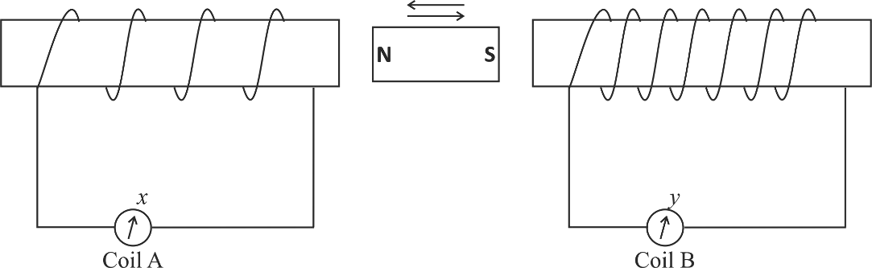A magnet kept at the centre of two coils A and B is moved to and fro as shown in the diagram. The two galvanometers show deflection.
Soft
iron
Soft
iron

State with a reason whether:
x > y
or
x < y. [x and y are magnitudes of deflection.]
[2]

- (i) Why is a nuclear fusion reaction called a thermo nuclear reaction?

(ii) Complete the reaction:

3He2 + 2H1 4He2 + …………….. + Energy
[2]

- State two ways to increase the speed of rotation of a D.C. motor. [2]

SECTION II (40 Marks)
Attempt any four questions from this Section

Question 5
- A body of mass 10 Kg is kept at a height of 5 m. It is allowed to fall and reach the ground.
  - What is the total mechanical energy possessed by the body at the height of 2 m assuming it is a frictionless medium?
  - What is the kinetic energy possessed by the body just before hitting the ground? Take g = 10 m / s2.

[3]

- A uniform meter scale is in equilibrium as shown in the diagram:

  - Calculate the weight of the meter scale.

  - Which of the following options is correct to keep the ruler in equilibrium when 40 gf wt is shifted to 0 cm mark?
F is shifted towards 0 cm.
or
F is shifted towards 100 cm.
[3]

- The diagram below shows a pulley arrangement:

Load
B
E
A
  - Copy the diagram and mark the direction of tension on each strand of the string.
  - What is the velocity ratio of the arrangement?
  - If the tension acting on the string is T, then what is the relationship between T and effort E?
  - If the free end of the string moves through a distance x, find the distance by which the load is raised.
[4]

Question 6
- How does the angle of deviation formed by a prism change with the increase in the angle of incidence?
Draw a graph showing the variation in the angle of deviation with the angle of incidence at a prism surface.

[3]

- A virtual, diminished image is formed when an object is placed between the optical centre and the principal focus of a lens.
  - Name the type of lens which forms the above image.

  - Draw a ray diagram to show the formation of the image with the above stated characteristics.
[3]

- An object is placed at a distance 24 cm in front of a convex lens of focal length 8 cm.
  - What is the nature of the image so formed?

  - Calculate the distance of the image from the lens.

  - Calculate the magnification of the image.
[4]

Question 7
- It is observed that during march-past we hear a base drum distinctly from a distance compared to the side drums.
  - Name the characteristic of sound associated with the above observation.

  - Give a reason for the above observation.

[3]

- A pendulum has a frequency of 4 vibrations per second. An observer starts the pendulum and fires a gun simultaneously. He hears the echo from the cliff after 6 vibrations of the pendulum. If the velocity of sound in air is 340 m/s, find the distance between the cliff and the observer.
[3]

- Two pendulums C and D are suspended from a wire as shown in the figure given below. Pendulum C is made to oscillate by displacing it from its mean
position. It is seen that D also starts oscillating.
[4]

wire
C
D

  - Name the type of oscillation, C will execute.

  - Name the type of oscillation, D will execute.

  - If the length of D is made equal to C then what difference will you notice in the oscillations of D?
  - What is the name of the phenomenon when the length of D is made equal to C?

Question 8
- (i) Write one advantage of connecting electrical appliances in parallel combination.
- What characteristics should a fuse wire have?

- Which wire in a power circuit is connected to the metallic body of the appliance?

[3]

- The diagram below shows a dual control switch circuit connected to a bulb.

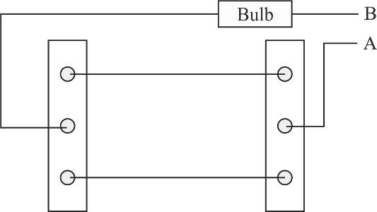
  - Copy the diagram and complete it so that the bulb is switched ON.

  - Out of A & B which one is the live wire and which one is the neutral wire?
[3]

(c)

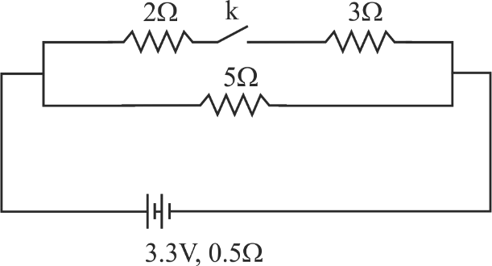

The diagram above shows a circuit with the key k open. Calculate:

- the resistance of the circuit when the key k is open.

- the current drawn from the cell when the key k is open.

- the resistance of the circuit when the key k is closed.

- the current drawn from the cell when the key k is closed.
[4]

Question 9
- (i) Define Calorimetry.

  - Name the material used for making a Calorimeter.

  - Why is a Calorimeter made up of thin sheets of the above material answered in (ii)?

[3]

- The melting point of naphthalene is 80°C and the room temperature is 30°C. A sample of liquid naphthalene at 100°C is cooled down to the room temperature. Draw a temperature time graph to represent this cooling. In the graph, mark the region which corresponds to the freezing process.
[3]

- 104 g of water at 30°C is taken in a calorimeter made of copper of mass 42 g. When a certain mass of ice at 0°C is added to it, the final steady temperature of the mixture after the ice has melted, was found to be 10°C. Find the mass of ice added. [Specific heat capacity of water = 4.2 Jg-1°C-1; Specific latent heat of fusion of ice = 336 Jg-1; Specific heat capacity of copper = 0.4 Jg-1°C-1]
[4]

Question 10

- Draw a neat labeled diagram of an A.C. generator. [3]

- (i) Define nuclear fission.

(ii) Rewrite and complete the following nuclear reaction by filling in the atomic number of Ba and mass number of Kr:
[3]

235 1
144
....... 1

92𝑈 + 0𝑛 →
........𝐵𝑎 +
36𝐾𝑟 + 3 0𝑛 + 𝐸𝑛𝑒𝑟𝑔𝑦

- The diagram below shows a magnetic needle kept just below the conductor AB
which is kept in North South direction.

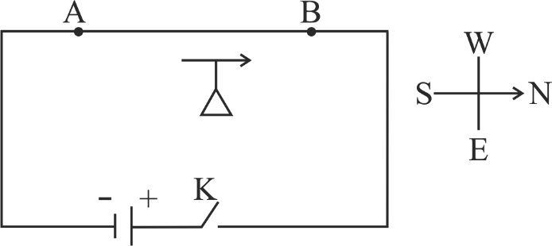

  - In which direction will the needle deflect when the key is closed?

  - Why is the deflection produced?

  - What will be the change in the deflection if the magnetic needle is taken just above the conductor AB?
  - Name one device which works on this principle.
[4]

