GEOGRAPHY
H.C.G. - Paper – 2
(Two hours)

Answers to this Paper must be written on the answer sheet provided separately.
You will not be allowed to write during the first 15 minutes.
This time is to be spent in reading the question paper.
The time given at the head of this Paper is the time allowed for writing the answers.

Attempt seven questions in all.
Part I is compulsory. All questions from Part I are to be attempted.
A total of five questions are to be attempted from Part II.
The intended marks for questions or parts of questions are given in brackets [ ].

Note:
To be supplied with this Paper: Survey of India Map Sheet No. 45D/10
and 20 cm of twine.

- In all Map Work, make wise use of arrows to avoid overcrowding of the map.
- The extract of Survey of India Map Sheet No. 45D/10 must not be taken out of the examination hall. It must be handed over to the Supervising Examiner on completion of the paper.
- The Map given at the end of this question paper must be detached, and after marking, must be fastened to your answer booklet.
- All sub-sections of the questions attempted must be answered in the correct serial order.
- All working including rough work should be done on the same answer sheet which is used to answer the rest of the paper.

This Paper consists of 9 printed pages and 1 outline map.
T19 502 Turn over
© Copyright reserved

PART I (30 Marks)

Attempt all questions from this Part

Question 1
Study the extract of the Survey of India Map sheet No. 45D/10 and answer the following questions:
  - (i) Give the six-figure grid reference for the temple that is located to the south west of Pithapura settlement.
(ii) Give the four-figure grid reference for a settlement where people of the region
meet socially and for trade at least once in a year.

[2]

  - (i) What is the pattern of drainage seen in the grid square 2118?

(ii) What is the pattern of settlement seen in the grid square 1923?
[2]

  - What do each of the two numbers (281 printed in black colour and 20 printed in red colour) in the grid square 1818 indicate?
[2]

  - (i) Name any two man-made features in grid square 2419.

(ii) Name any two natural features in grid square 2118.
[2]

  - What is the significance of the following?

    - Fire line in grid square 2417.

    - Water body found in grid square 2221.
[2]

  - Calculate the area of the region between 16 and 19 Eastings and 18 and 22
Northings. Give your answer in kilometre square.
[2]

  - Give a reason for each of the following:

    - The water in some of the wells in the north west quarter of the map is not fit for drinking.
    - The region near Anadra and Gulabganj has many causeways.
[2]

  - (i) What is the main means of irrigation used by people living in the area shown on the map?
(ii) What is the main occupation of the people of the region shown on the map?
[2]

  - Which according to you is the most important settlement? Give a reason to support your answer.
[2]

  - Name any two means of transport used by the people living in the area shown on the map extract.
[2]

Question 2
On the outline map of India provided:

(a)  (b) | Shade and label the Gangetic Plain.  Shade and label an area of laterite soil in North India. | [1]  [1]
(c) | Mark and label the Karakoram Mountains. | [1]
(d)  (e) | Mark and name the Palk Strait.  Shade and label the river Cauveri. | [1]  [1]
(f)  (g) | Mark and name Mumbai.  Mark and name the Nathu La Pass. | [1]  [1]
(h)  (i) | Mark and name Digboi.  Shade and name the Deccan Plateau. | [1]  [1]
(j) | Shade and label the river Jhelum. | [1]

PART II (50 Marks)
Attempt any five questions from this Part

Question 3
- (i) What type of wind is ‘Monsoon’? What is its direction during summer?

(ii) Mention two characteristics of the Indian monsoon.

[2]

- With reference to the summer season in India, answer the following questions:

  - Mention the duration of the summer season in India.

  - What is the atmospheric pressure condition during summer season over the
central part of India?
[2]

- Give a reason for each of the following:

  - Goa receives heavier rainfall than Puducherry.

  - Mawsynram receives the highest average annual rainfall.

  - Mangaluru is cooler than Delhi in summer season.
[3]

- Study the data of distribution of temperature and rain for Station X and answer the questions that follow:
[3]

Month | JAN | FEB | MAR | APR | MAY | JUN | JUL | AUG | SEP | OCT | NOV | DEC
Temp.  °C | 10 | 11 | 23 | 35 | 39 | 42 | 40 | 33 | 30 | 25 | 13 | 11
Rainfall Cm | 2 | 1 | 0 | 5 | 15 | 62 | 71 | 81 | 59 | 12 | 10 | 3

  - Is Station X in the coastal area or in the interior of the country?

  - Calculate the total annual rainfall for Station X.

  - Name the wind that brings most of the rainfall to Station X.

Question 4

- (i) Name the Indian soil which is formed due to the weathering of basic igneous rocks.
(ii) Name two states of India where this type of soil is found.
[2]

- Name the following:

  - An important transported soil of India.

  - Soil that is rich in iron oxide.
[2]

- Give a geographical reason for each of the following:

  - Terrace farming is an ideal soil conservation method for hilly regions.

  - Dry farming is preferred in areas with red soil.

  - Wind is a common agent of soil erosion in arid regions.
[3]

- Briefly answer the following:

  - Mention one way in which man is responsible for soil erosion.

  - How can deepening of the river bed help in preventing soil erosion?

  - Mention a physical characteristic of Laterite soil.
[3]

Question 5
- Give two reasons to explain as to why we need to conserve our forest resource. [2]

- (i) Mention two conditions required for the growth of Littoral Forest.

(ii) State one characteristic feature of the forest found in the Nilgiri Hills.
[2]

- (i) Give two reasons to explain as to why the Tropical Evergreen Forests are difficult to exploit for commercial purpose.
(ii) Name any two trees found in Tropical Evergreen forests.
[3]

- Briefly explain each of the following:

  - The trees in the Tropical Desert Forest have stunted growth.

  - There is a gradual increase in the forest cover in India in recent times.

  - The trees in Monsoon Deciduous forests, shed their leaves for about 6-8 weeks during March and April.
[3]

Question 6
- “The modern means of irrigation are gaining popularity.”
Give two reasons to justify this statement.

[2]

- Mention two factors that favour the development of tube well irrigation in Punjab. [2]

- Give a reason for each of the following:

  - Most of the South Indian states are not suitable for development of canal irrigation.
  - There is an urgent need for water conservation in India.

  - Development of irrigation is essential for the growth of the agriculture sector of India.
[3]

- Briefly explain the following terms:

  - Inundation canal.

  - Rooftop rainwater harvesting.

  - Surface water.
[3]

Question 7
- Give two advantages of using bio-gas as a source of power. [2]

- Name the following:

  - A metallic mineral for which the Balaghat district of Madhya Pradesh is famous.
  - The multi-purpose project based on the River Sutlej.
[2]

- Give a reason for each of the following:

  - Odisha has benefitted greatly from the Hirakud project.

  - Copper is used to make electric wires.

  - India’s location is advantageous for the generation of solar power.
[3]

- Briefly answer the following:

  - Name a mineral used to generate nuclear power.

  - Why is petroleum often referred to as “liquid gold”?

  - State one disadvantage of using coal as a source of power.
[3]

Question 8
- Mention two steps taken by the government to boost agricultural production in India.

[2]

- (i) Name two varieties of millet grown in India.

(ii) What is the soil requirement for growing millet?
[2]

- Study the picture given below and answer the questions that follow:

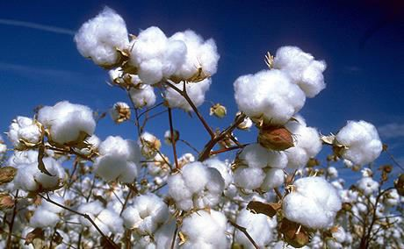

  - Mention the climatic condition that is suitable for the cultivation of this crop.

  - Name the state that produces the largest amount of this crop.

  - In which cropping season is this crop grown in India?
[3]

- Give a geographical reason for each of the following:

  - Cultivation of wheat is confined to the northern part of India.

  - Practicing mixed farming gives security to farmers.

  - Ratoon cropping is gaining popularity among sugarcane cultivators.
[3]

Question 9
- Where do the following iron and steel plants get their supply of iron ore from?

  - Bhilai Iron and Steel Plant.

  - Vishakhapatnam Steel Plant.

[2]

- ‘Karnataka has developed as an important state for the growth of the Silk industry.’
Give two reasons to justify the statement.
[2]

- With reference to sugar industries answer the following questions:

  - Why should these industries be located close to the sugarcane growing areas?

  - Name two by-products of the sugar industry.

  - Mention one leading sugar producing state in North India and one in South India.
[3]

- Give a reason for each of the following:

  - Ahmedabad is an important cotton textile producing centre in India.

  - Cottage industries are significant for our economy

  - Petrochemical industries are usually located close to the oil refineries.
[3]

Question 10
- “Roadways are an important means of transport in India”.
Give two reasons to justify the statement.

[2]

- (i) Why are South Indian rivers not ideal for the inland water transport?

(ii) Mention one advantage of coastal shipping.
[2]

- Give a reason for each of the following:

  - Nearly seventy percent of Indians do not use air transport.

  - A well-developed transport network is important for industrial growth.

  - Water transport is not as popular as land transport in India.
[3]

- (i) “The railway is an important means of transport as compared to airways.”
State two reasons to support the statement.

(ii) Mention one disadvantage of rail transport.
[3]

Question 11
- What impact does the waste accumulation have on the following?

  - Quality of air around us.

  - Quality of water around us.

[2]

- Mention two ways in which the decomposition of waste in open areas can affect human health.
[2]

- (i) What can an individual do to reduce waste at home?

- Why must segregation of waste be done before disposal?

- How has composting proven to be a great help in managing waste?
[3]

- Give a reason for each of the following:

  - Trees must be planted in the industrial areas.

  - Chemical fertilizers must be replaced by organic manure.

  - Plastic and polythene products must be banned.
[3]

Question No. 2
Index No.……………………………………………. UID……………………………..
(This map, if used, must be fastened with all other answers)
Map of India for Question 2.

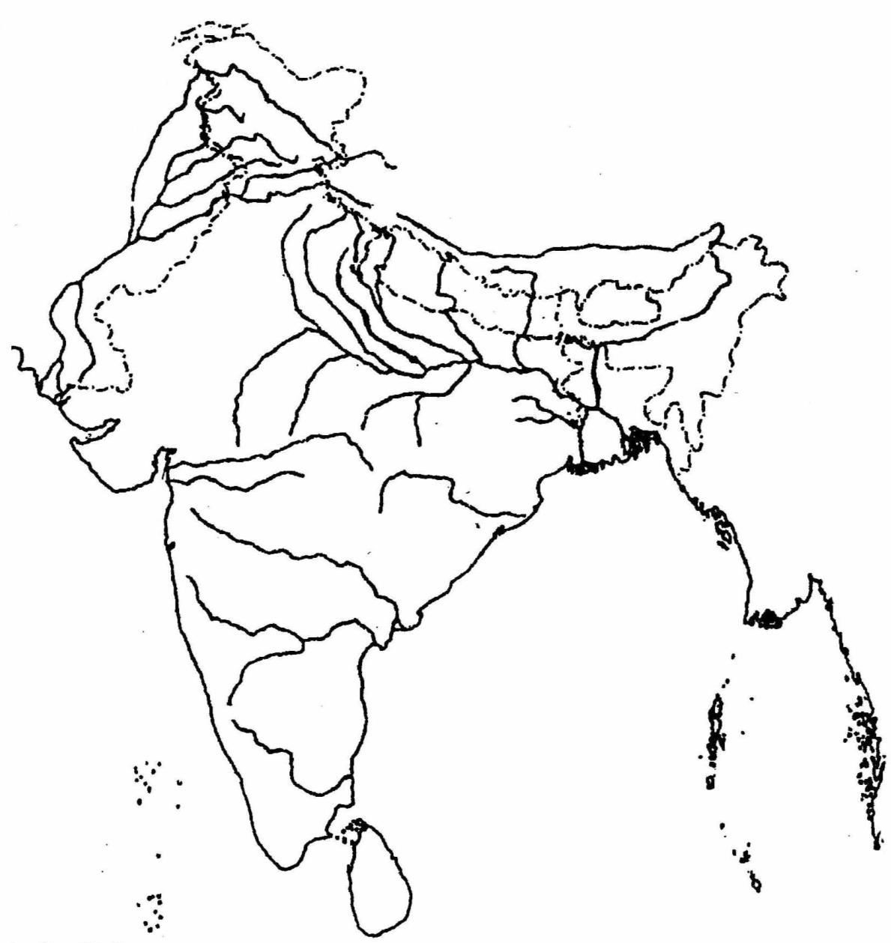

ONLY FOR THE EXAMINER
a | b | c | d | e | f | g | h | i | j | Total

T19 502 10

