ENGLISH LANGUAGE

ENGLISH Paper – 1

(Two hours)

Answers to this Paper must be written on the paper provided separately.

You will not be allowed to write during the first 15 minutes.

This time is to be spent in reading the question paper.

The time given at the head of this Paper is the time allowed for writing the answers.

Attempt all five questions.

The intended marks for questions or parts of questions are given in brackets [ ].

You are advised to spend not more than 30 minutes in answering Question 1 and 20 minutes in answering Question 2.

Question 1

(Do not spend more than 30 minutes on this question.)

Write a composition (300 - 350 words) on any one of the following: [20]

- Write an original short story in which two children and their Grandfather are the main characters.
- Closed Circuit Television (CCTV) must be installed in every class room.
Give your views either for or against this statement.

- Your class had to conduct a Morning Assembly. Write an account of how you prepared for it, what your role was and what you gained from the experience.
- Summers are becoming hotter with each passing year. Write a description of one such very hot day. What did you see and hear as you walked outside? How were birds and animals affected?

This Paper consists of 6 printed pages.
T19 011 Turn Over
© Copyright Reserved

- Study the picture given below. Write a story or a description or an account of what it suggests to you. Your composition may be about the subject of the picture or you may take suggestions from it; however, there must be a clear connection between the picture and your composition.

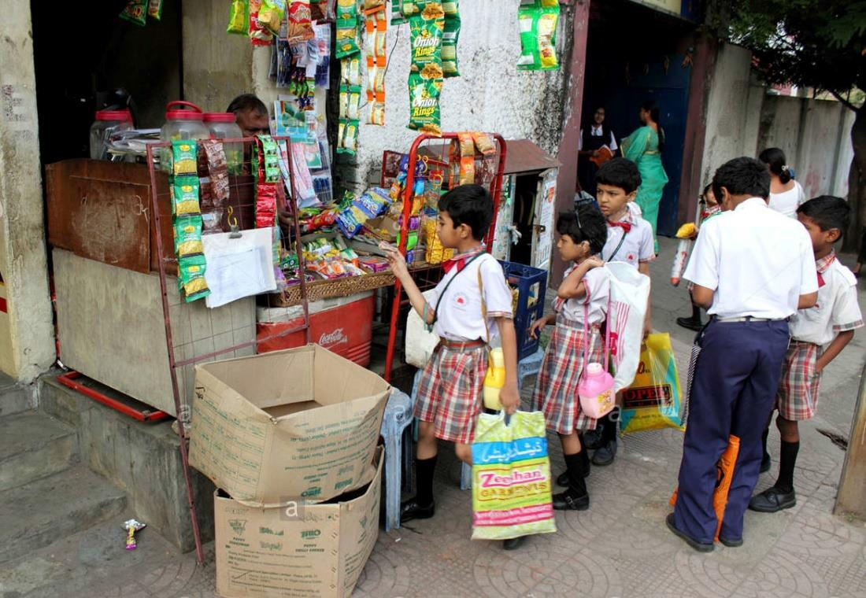

Question 2
(Do not spend more than 20 minutes on this question.)
Select any one of the following:
- You want to start a new club in your school.

Write a letter to your Principal requesting permission to start the club, explain your role in it and give reasons to prove that the club will be beneficial for the school.
- Your friend has not fared well in the recent examinations. Write a letter to him / her expressing your concern. Give him / her some advice on how to score better marks and offer to help him / her to improve his / her performance.
[10]

Question 3
- Your school is hosting an Inter-School Quiz Competition.

Write out a notice to be displayed in your school giving all details for the event.

[5]

- Write an e-mail to the Principal of a neighbouring school requesting him / her to send a team of three members to participate in the Quiz Competition.
[5]

Question 4
Read the following passage carefully and answer the questions that follow:

Billy Weaver had travelled down from London and by the time he arrived it
was nine o’clock in the night and the moon was coming up. “Excuse me,” he asked a porter. “but is there a cheap hotel nearby?” “Try The Bell Hotel,” the porter answered, pointing down the road.
Billy thanked him, picked up his suitcase and set out to walk the distance to The Bell Hotel. He had never been to Richmond before. But the man at the Office had told him it was a splendid city.
Billy was seventeen years old. He was wearing a new navy-blue overcoat, a new brown hat, and a new brown suit, and he was feeling fine. He walked
briskly down the street. He was trying to do everything briskly these days. The 10
big shots up at the Head Office were fantastically brisk all the time. They were amazing.
The road was lonely and dark with a few scattered houses.

Suddenly, in a downstairs window Billy saw a printed notice propped up against the window glass. It said Bed and Breakfast.
He moved a bit closer and peered through the window into the room, and the first thing he saw was a bright fire burning in the hearth. On the carpet in front of the fire, a little dog was curled up asleep with its nose tucked into its belly. The room in half-darkness was filled with pleasant furniture. There was a

piano and a big sofa and several plump armchairs; and in one corner he spotted 20
a large parrot in a cage. Animals were usually a good sign in a place like this, Billy told himself and it looked to him as though it would be a pretty decent house to stay in.
Then a queer thing happened to him. He was in the act of stepping back and going away from the window when he felt a strange urge to ring the bell!
He pressed the bell. He heard it ringing, and then at once the door swung open and a woman was standing there.
She gave him a warm welcoming smile.

“Please come in,” she said pleasantly. Billy found himself automatically
moving forward into the house. 30
“I saw the notice in the window,” he said, holding himself back. “Yes, I know.”
“I was wondering about a room.”

“It’s all ready for you, my dear,” she said. She had a round pink face and very
gentle blue eyes.

“How much do your charge?”

“Five dollars a night, including breakfast.”

It was fantastically cheap. He could easily afford it.

- Give the meaning of the following words as used in the passage: One-word answers or short phrases will be accepted.
  - splendid (line 7)
  - spotted (line 20)
  - automatically (line 29)
[3]

- Answer the following questions briefly in your own words.

  - How did the porter assist Billy? [2]

  - Why did Billy want to do everything briskly? [2]

  - Why did Billy think animals were a good sign in a place like this? [2]

  - Which sentence tells you that something strange happened to Billy? [2]

  - How much did the room cost? [1]

- In not more than 50 words, give a brief account of what Billy saw as he looked through the window of the room.
[8]

Question 5
- Fill in each of the numbered blanks with the correct form of the word given in brackets. Do not copy the passage, but write in correct serial order the word or phrase appropriate to the blank space.

Example:
(0) roamed
Once upon a time, in the days when genies and giants (0) (roam) the land, there (1) (live) a farmer (2) (name) Baba Ayub. He lived with his family in a little village by the name of Maidan Sabz. Because he had a large family to feed, Baba Ayub (3) (see) his days (4) (consume) by hard work. Every day, he (5) (labour) from dawn to sundown, (6) (plow) his field and (7) (turn) the soil and (8) (tend) to his meagre pistachio trees.

[4]

- Fill in each blank with an appropriate word:

  - The puppy was hiding the sofa.

  - Stop worrying your future.
[4]

  - When I stepped the lift, I found it had stopped working.

  - We had to use a bridge to go the river.

  - I have lived in this town ten years.

  - Please switch _ all lights and fans when you leave the room.

  - Ronnie is married my cousin.

  - The gift came a birthday card.

- Join the following sentences to make one complete sentence without using
and, but or so:
  - He was very ill. He did not take any medicine.

  - You come back from your holiday. We will discuss the problem.

  - He remained absent on Friday. It was foolish of him.

  - Rahul ran all the way to the bus stop. He missed the bus.

- Re-write the following sentences according to the instructions given after each. Make other changes that may be necessary, but do not change the meaning of each sentence.
  - The old woman said to Arun, “Can you help me to cross the street?”
(Begin: The old woman asked Arun …………………)

  - As soon as the sun rose over the hills, the fog disappeared. (Begin: No sooner…………………)
  - It rained so heavily that they could not go for the picnic. (Rewrite: Using ‘too …………………to’)
  - If your friends get here before 7 o’clock we can take them out for dinner.
(Rewrite: Using ‘unless’.)

  - The school captain was elected by the students of classes XI and XII. (Begin: The students…………………)
  - Greenland is the largest island in the world. (Rewrite: Using ‘larger’.)
  - How cruel Shylock was to demand his pound of flesh! (Begin: It was cruel…………………)
  - Arun was asked by his mother to explain the missing buttons on his shirt. (Rewrite: Using ‘explanation’)
[4]

[8]

