BIOLOGY

SCIENCE Paper – 3

(Two hours)

Answers to this Paper must be written on the paper provided separately.

You will not be allowed to write during the first 15 minutes.

This time is to be spent in reading the Question Paper.

The time given at the head of this Paper is the time allowed for writing the answers.

Attempt all questions from Section I and any four questions from Section II. The intended marks for questions or parts of questions are given in brackets [ ].

SECTION I (40 Marks)

Attempt all questions from this Section

Question 1

- Name the following: [5]

  - The process of transformation of several glucose molecules into one molecule of starch.
  - The point of attachment of two chromatids.

  - The iron containing pigment in erythrocytes.

  - The duct which transports urine from the kidney to the urinary bladder.

  - The part of the brain which is concerned with memory.

This paper consists of 11 printed pages and 1 blank page.
T20 523 Turn Over
© Copyright reserved

- Explain the following terms:

  - Allele

  - Diffusion

  - Photolysis

  - Phenotype

  - Population density
[5]

- Given below are certain groups of terms. In each group the first pair indicates a relationship between the two terms. Rewrite and complete the second pair on a similar basis.
Example: Cytoplasm : Cytokinesis :: Nucleus : Karyokinesis.
[5]

  - Widening of hips: Oestrogen :: Deepening of voice in males : .

  - Brain : Meninges :: Heart : .

  - Insulin : Beta-cells :: Glucagon : .

  - Kidney: Renal artery :: Liver : .

  - Uterus : Implantation :: Fallopian tube : .

- Given below are sets of five terms each. Rewrite the terms in correct order in a logical sequence beginning with the first word that is underlined:
  - Stimulus, Response, Receptor, Effector, Spinal cord.
[5]

  - Root hair, Endodermis, Epidermis, Xylem, Cortex.

  - Conjunctiva, Yellow spot, Pupil, Vitreous Humour, Aqueous Humour.

  - Australopithecus, Cro-Magnon Man, Homo erectus, Neanderthal Man, Homo sapiens.
  - Artery, Capillaries, Venule, Vein, Arteriole.

- Choose the correct answer from the four options given below:

  - The fusion of the sperm and ovum is termed as:
    - Reproduction
    - Development
    - Fertilization
    - Embryo

  - Agranulocytes are:
    - Lymphocytes, Monocytes
    - Lymphocytes, Basophils
    - Eosinophils, Basophils
    - Eosinophils, Monocytes

  - Which of the following is not a natural reflex action?
    - Knee-jerk
    - Blinking of eyes due to strong light
    - Salivation at the sight of food
    - Sneezing when any irritant enters the nose

  - The structural and functional units of excretion in the human kidney is the:
    - Ureter
    - Bowman’s capsule
    - Renal pelvis
    - Nephron

  - In a human female, ovum consists of:
    - 23 pairs of autosomes
    - 22 pairs of autosomes and 1 pair of sex chromosomes
    - 22 autosomes and 1 Y-chromosome
    - 22 autosomes and 1 X-chromosome
[5]

- Identify the ODD term in each set and name the CATEGORY to which the remaining three belong:
  - Auxin, Ethylene, Adrenaline, Cytokinin

  - Tympanum, Ear ossicles, Auditory canal, Pinna

  - Syringes, Soiled dressings, Discarded needles, Household detergents

  - Exophthalmic Goiter, Simple Goitre, Cretinism, Myxoedema

  - Adenine, Guanine, Creatinine, Cytosine
[5]

- Match the items given in column A with the most appropriate ones in Column B and REWRITE the correct matching pairs:

Column A Column B

  - Biston betularia - Calcium

  - Testes - balance of the body

  - Clotting of blood - Light independent reaction

  - Stroma - diffusion of gases

  - Stomata - gonad

- Peppered moth

- Light dependent reaction

- Chlorophyll
[5]

- 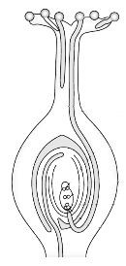The diagram given below represents a plant movement. Answer the following questions:

A
[5]

  - Name the tropic movement shown in the diagram.

  - Explain the tropic movement mentioned in (i).

  - Label the part marked ‘A’.

  - What is part A attracted to?

  - Give an example of a plant which shows Thigmotropism.

SECTION II (40 Marks)
Attempt any four questions from this Section.

Question 2
- The diagram given below represents an experiment to prove the importance of a factor in photosynthesis. Answer the questions that follow:

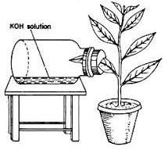
KOH solution
A

  - Which factor is being studied here?

  - What is the purpose of keeping KOH in the flask?

  - Explain the term Photosynthesis.

  - What will you observe when the leaf A is tested for starch?

  - Write a well balanced chemical equation for the process of photosynthesis.

[5]

- The diagram given below represents the simplified pathway of the circulation of blood. Answer the questions that follow:
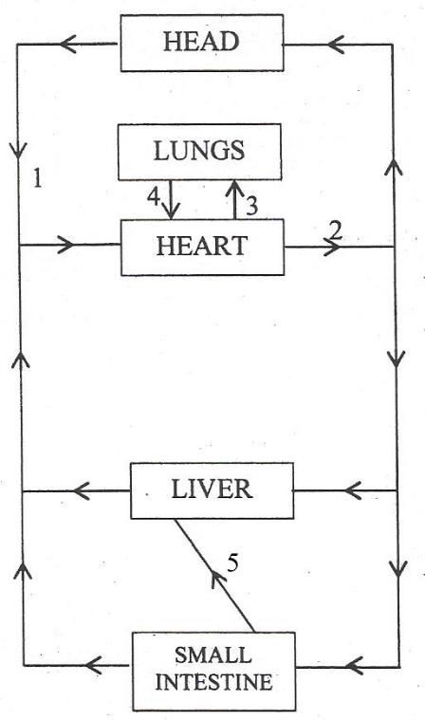
  - Name the blood vessels labelled 1 to 4.

  - Which blood vessel supplies oxygenated blood to the muscles of the heart?

  - What is the importance of blood vessel labelled 5?

  - What is the type of blood circulation that takes place between the heart and the lungs?
  - Draw a diagram of the different blood cells as seen in a smear of human blood.
[5]

Question 3
- The diagram given below depicts a defect of the human eye which has been corrected by using a suitable lens.
Answer the following questions:

[5]

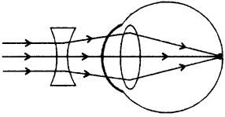

  - Name the defect that has been corrected.
Which type of lens has been used for the correction?

  - Mention one cause for the above defect.

  - Where would the image have formed if the above lens was not used for correction?
  - Name the three concentric layers of the eyeball.

  - Draw a neat, labelled diagram of a neuron.

- Give the biological reasons for the following statements:

  - It is advisable to keep green plants in an aquarium.

  - Water pollution is a major cause of concern in our country.

  - We cannot distinguish colours in dim light.

  - Medical discoveries such as antibiotics and vaccinations have indirectly contributed to the sharp rise in human population.
  - Homo sapiens sapiens is the most highly evolved form of man.
[5]

Question 4

- The figure given below shows a part of a nephron. Answer the questions that follow:
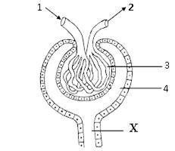
  - In which region of the kidney is the above structure present?
[5]

  - Label the parts numbered 1 to 4.

  - What is the technical term for the process that occurs in part 3? (iv)Why is fluid X not called urine? Justify your answer.
(v) Draw a neat, labelled diagram of the urinary system of man.

- Differentiate between the following pairs on the basis of what is mentioned in the brackets:
  - Transpiration and Guttation (place of occurrence)

  - Biodegradable waste and Non-biodegradable waste (One example)

  - Population control and Swachh Bharat Abhiyan (One objective)

  - Osmosis and Active Transport (Substances undergoing movement)

  - Metaphase and Anaphase (Position of chromosomes)
[5]

Question 5
- The diagram below represents an experiment to demonstrate a certain phenomenon in a green plant:
Transpiration

[5]

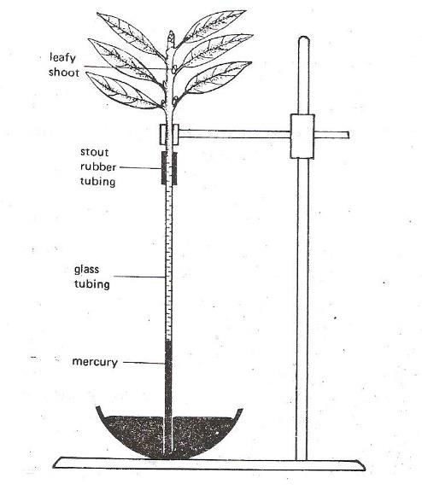

  - Will the level of mercury in the glass tubing rise or fall?
Which conducting tissue of the plant does the glass-tubing represent?

  - Define Transpiration.

  - How will the rate of the above process differ if the environment of the plant has:
    - Less humidity

    - High temperature?

  - State any two advantages of transpiration to the plant.

  - Draw a neat labelled diagram of a Plasmolysed cell.

- Give appropriate biological/ technical terms for the following:

  - The sensory organ in Cochlea.

  - Number of live births per 1000 people per year.

  - The point of contact between two neurons.

  - The accessory gland in human males whose secretion neutralises the acid in the vagina.
  - Condition when blood sugar level is lowered in the blood.

  - Structure which helps in the adjustment of the size of the pupil.

(vii) A surgical method of fertility control in human males.

- Process by which leucocytes migrate through the walls of capillaries.

- A sudden inheritable change in one or more genes.

- A non-dividing phase of the cell cycle where more DNA is synthesised.
[5]

Question 6
- State two functions of:

  - Ear

  - Ethylene

  - Tears

  - Testis

  - Cerebellum

[5]

- Complete the table:
[5]

Name of the Hormone | Endocrine Gland | Function
(i) | (ii) | Deposits extra glucose of blood as glycogen
Growth Hormone | (iii) | (iv)
(v) | Thyroid | (vi)
(vii) | (viii) | Prepare body for any emergency
Oxytocin | (ix) | (x)

Question 7
- A homozygous dominant tall pea plant bearing red flowers (TTRR) is crossed with a homozygous recessive dwarf pea plant bearing white flowers (ttrr).
  - What is the phenotype and genotype of F1 individuals?

  - Write the possible combination of gametes that are obtained when two F1 hybrid plants are crossed.
  - Mention the phenotypic ratio of the F2 generation.

  - State Mendel’s Law of Independent Assortment.

  - Name two X-linked disorders found in humans.

[5]

- The diagram given below is that of a developing human foetus. Answer the questions that follow:

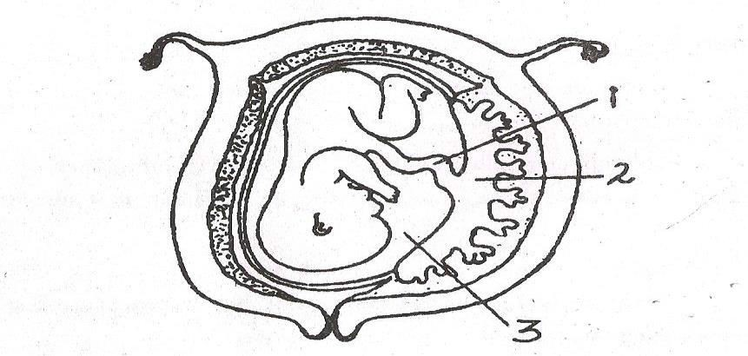

  - Label the parts numbered 1 to 3 in the diagram.

  - Mention any two functions of the part labelled 2 in the diagram.

  - Explain the significance of the part numbered 3 in the diagram.

  - Define the term ‘Gestation’.
What is the normal gestational period of the developing embryo?

  - Mention the sex chromosomes in a male and female embryo.
[5]

